**Day-44 practice (16/10/2024)**

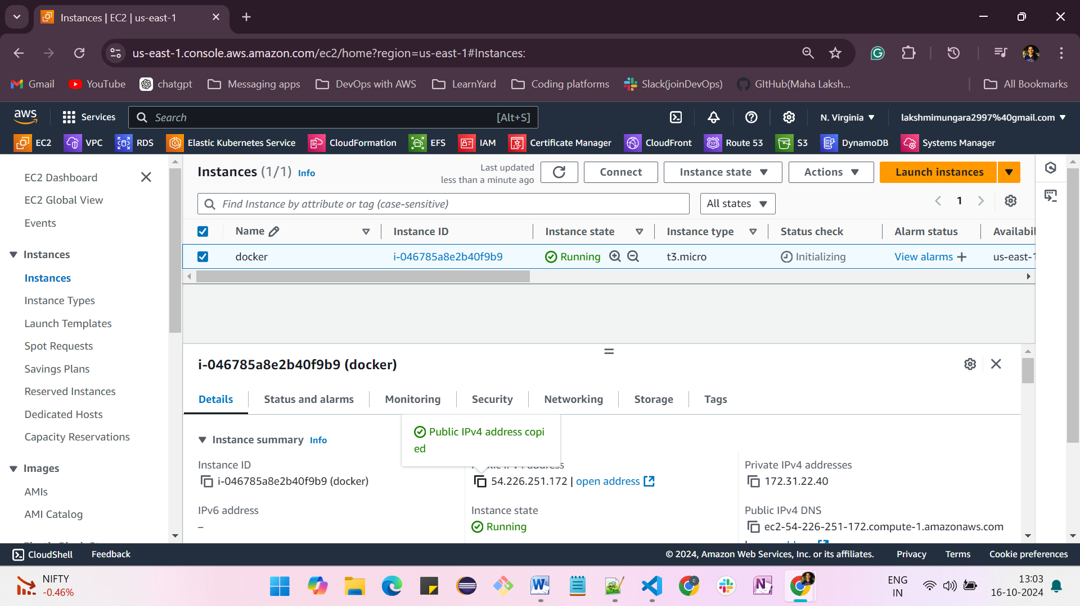

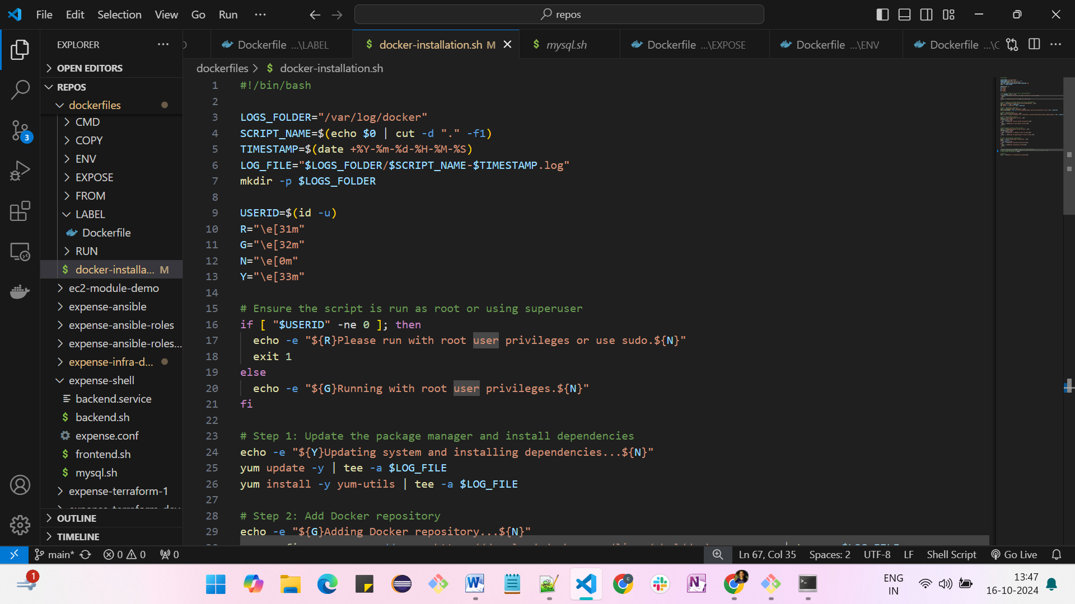

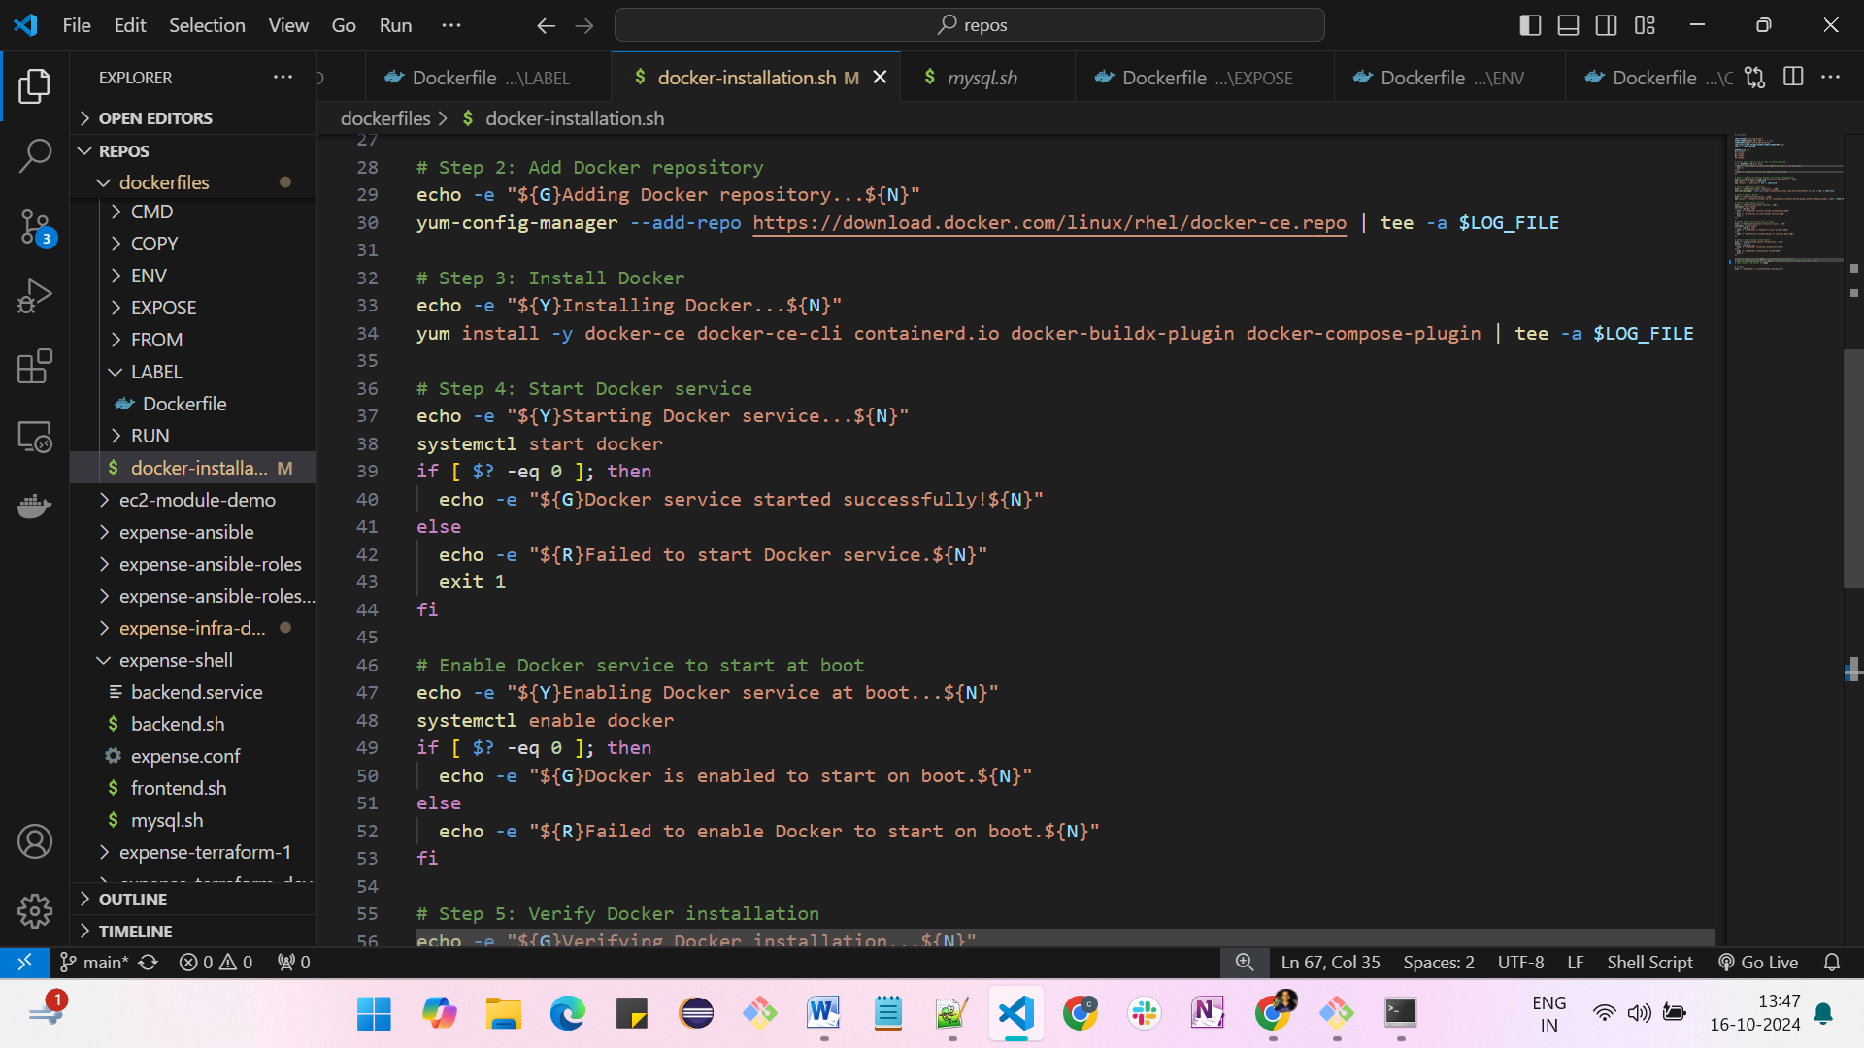

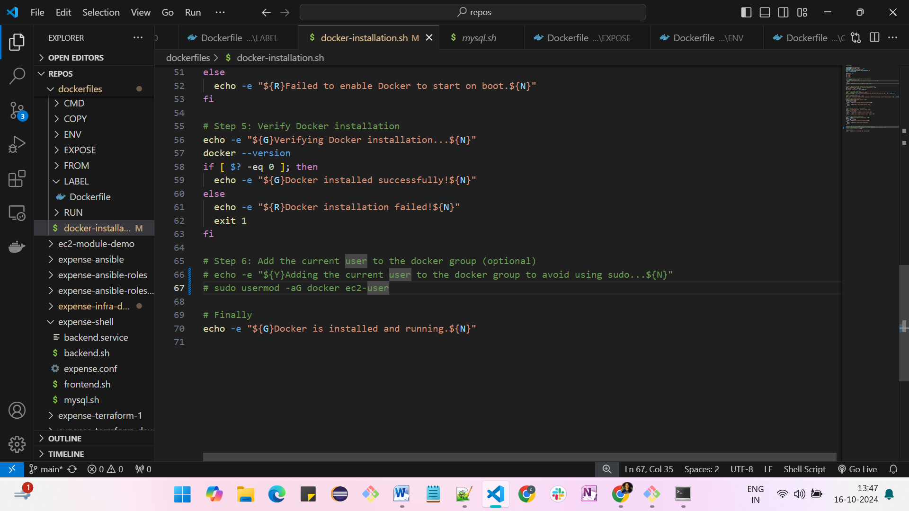

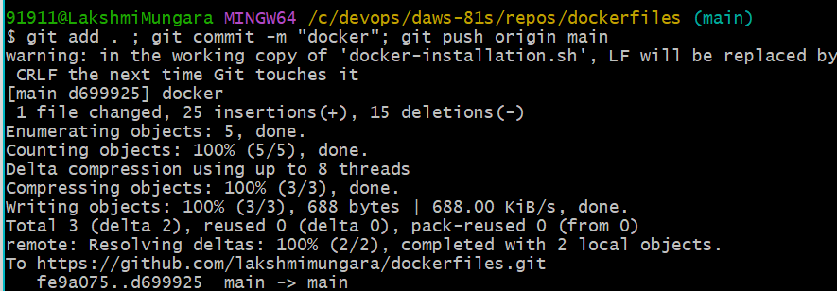

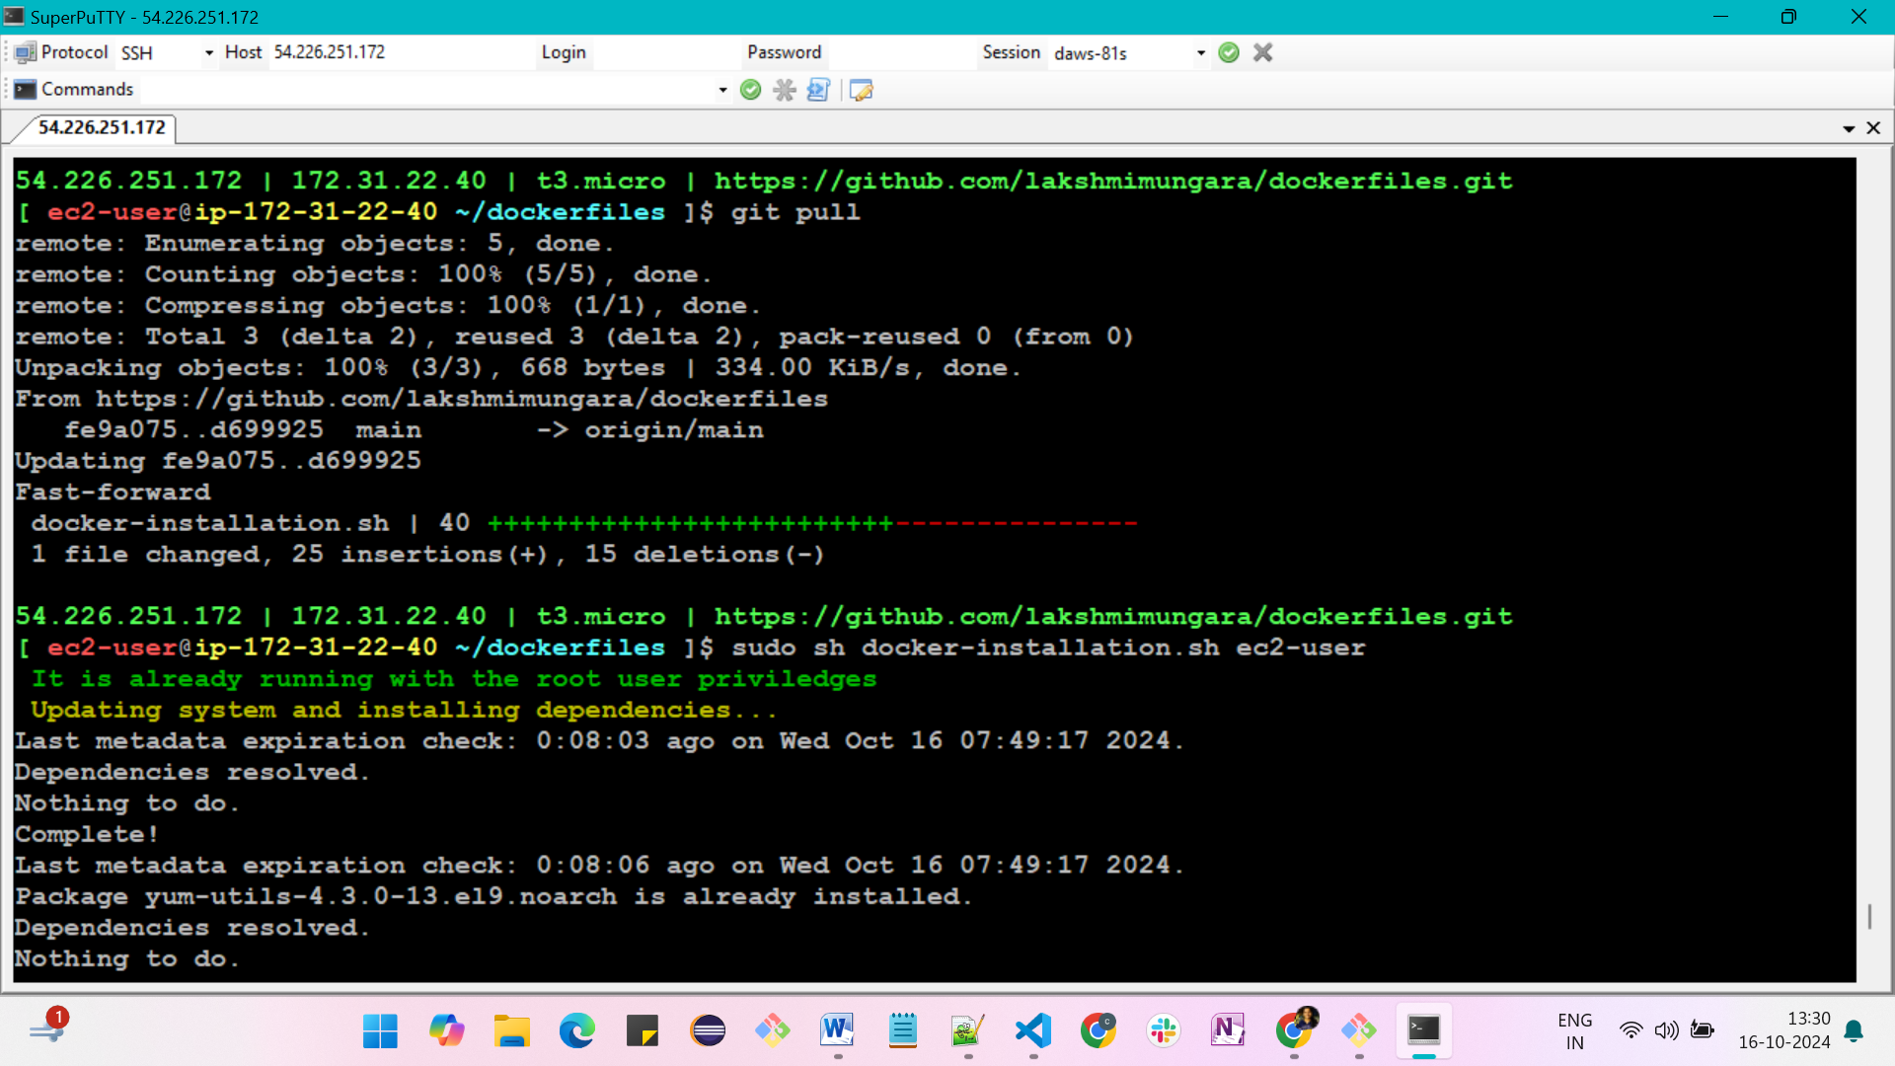

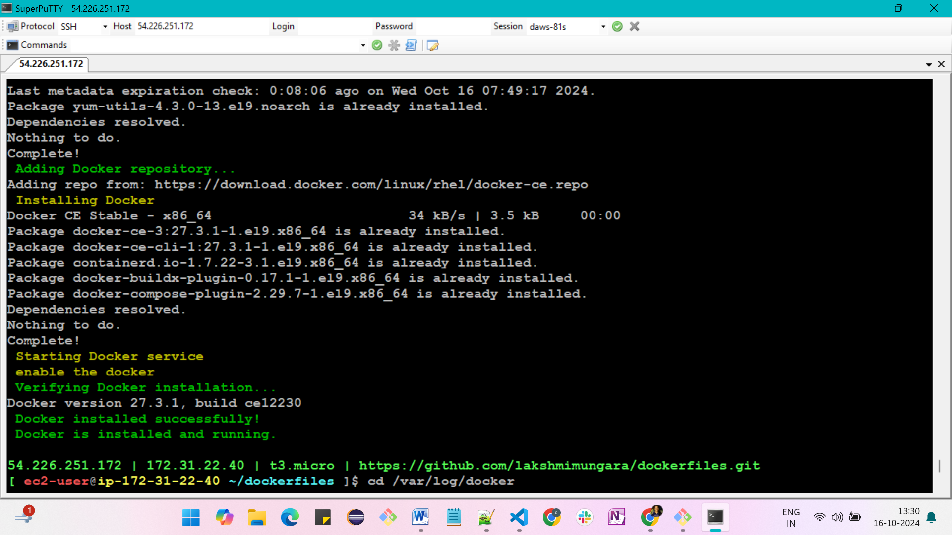

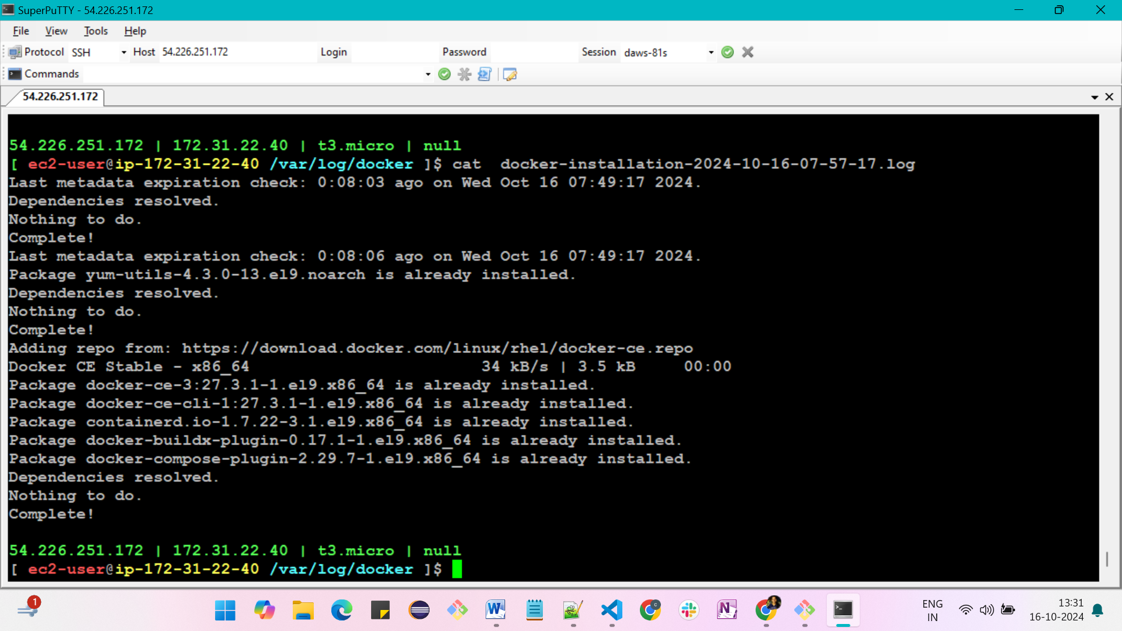

**sudo usermod –aG docker ec2-user**

**logout and login again**

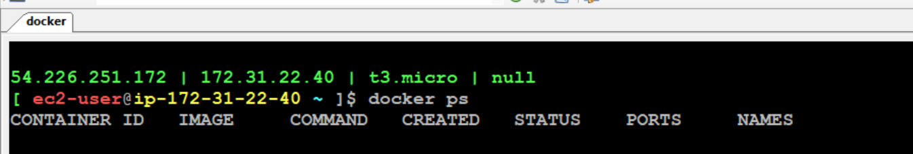

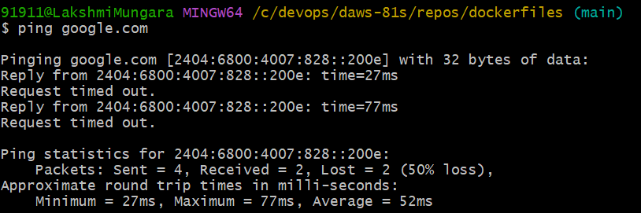

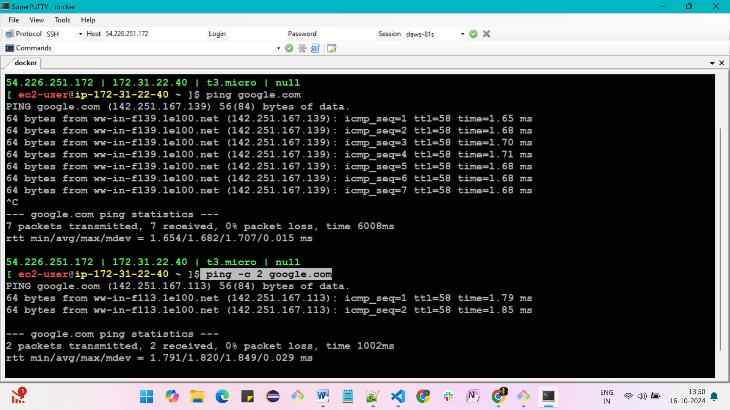

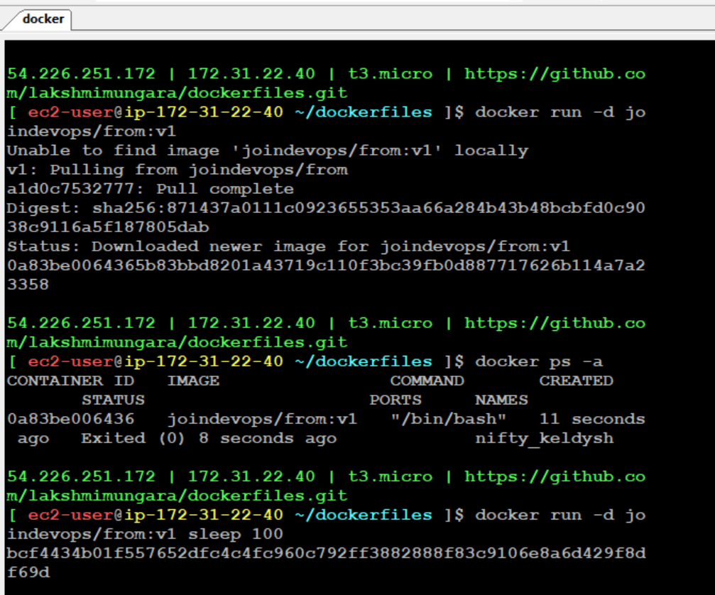

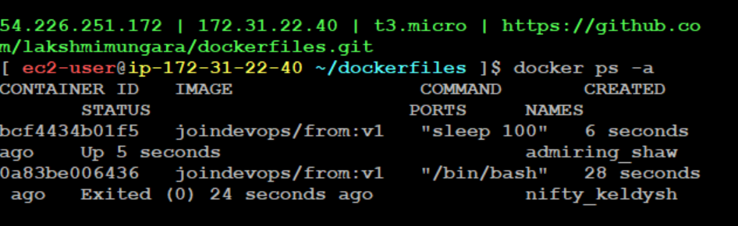

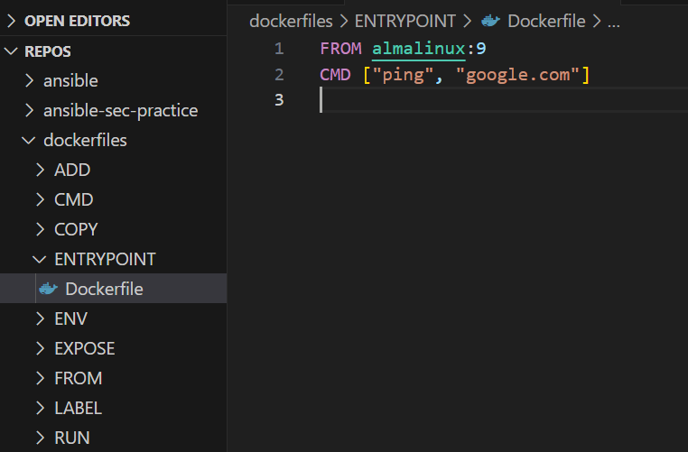

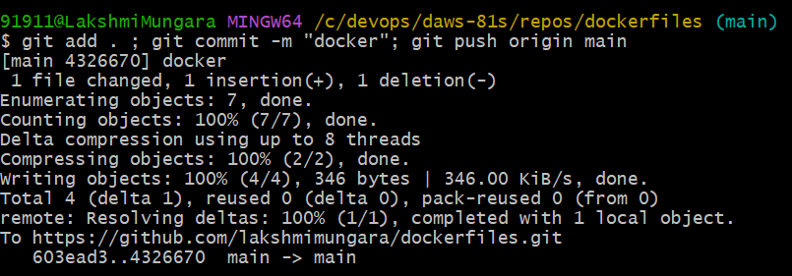

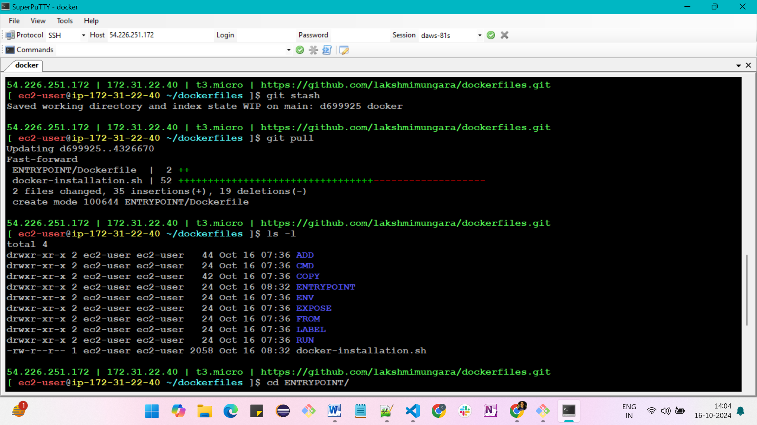

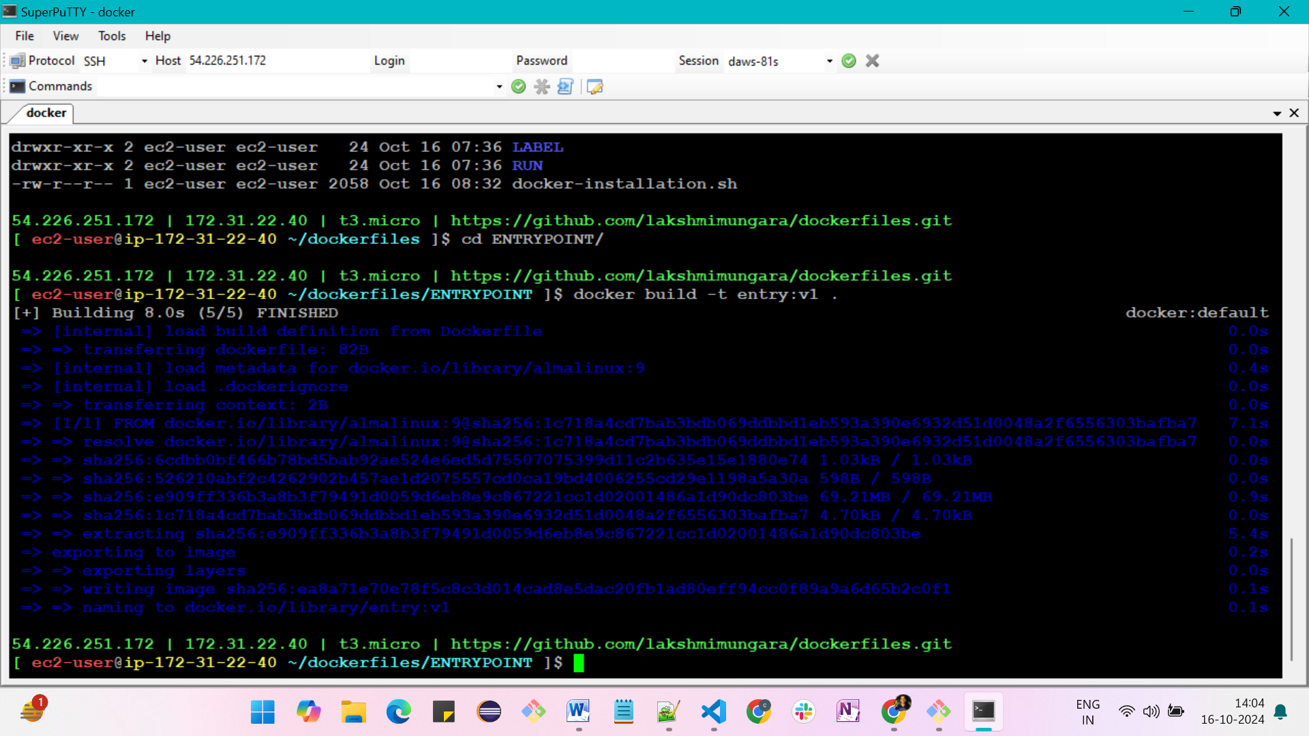

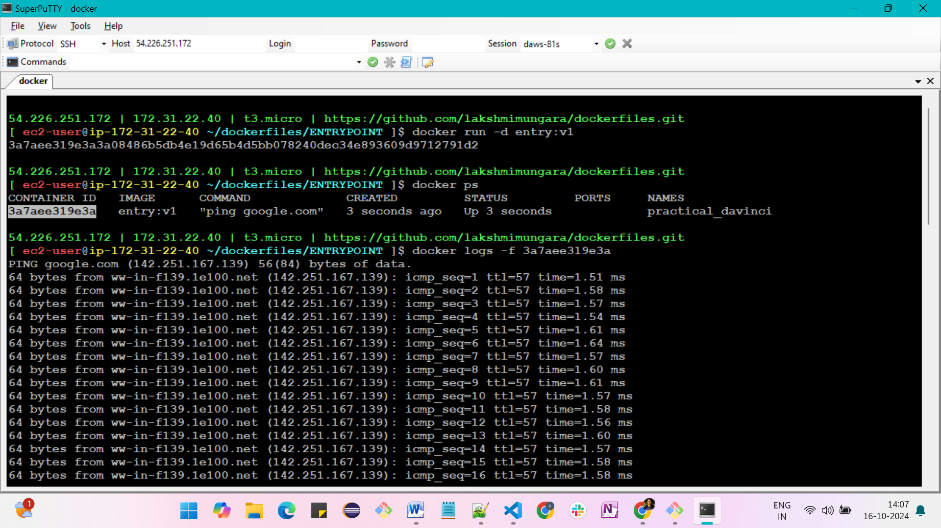

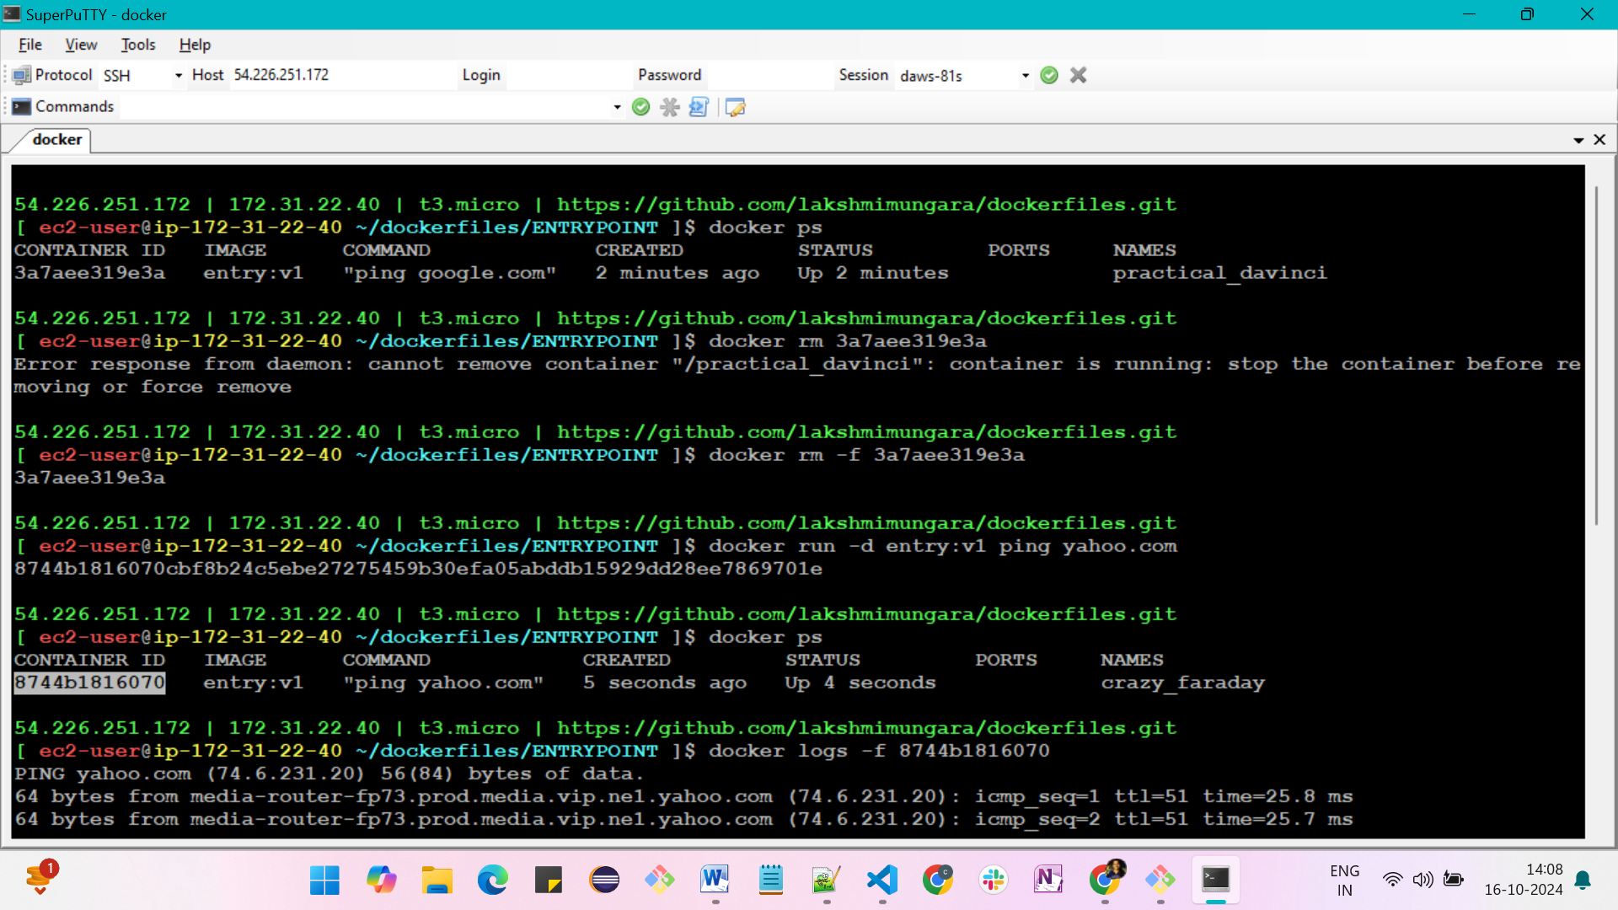

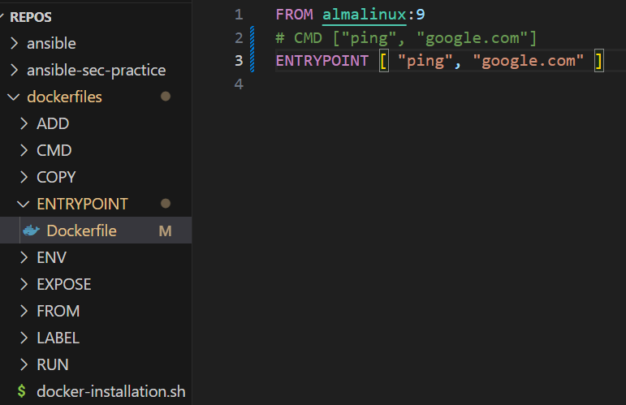

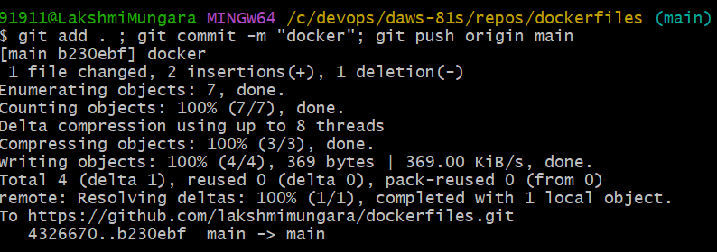

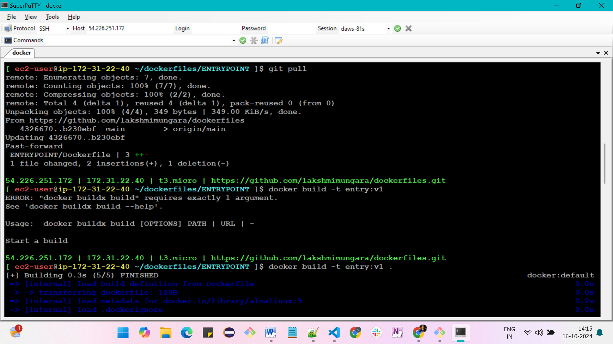

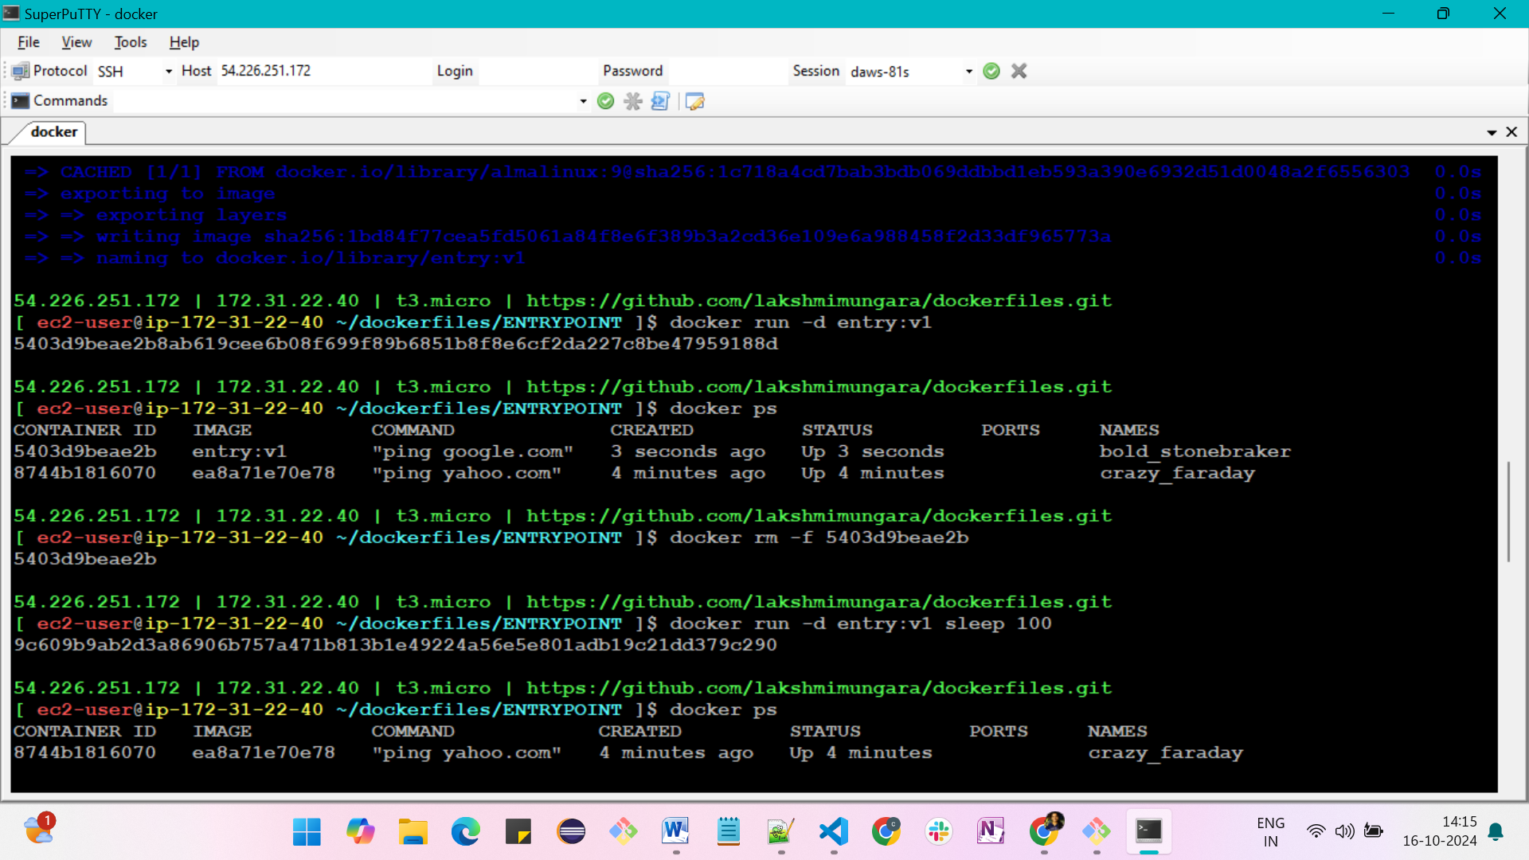

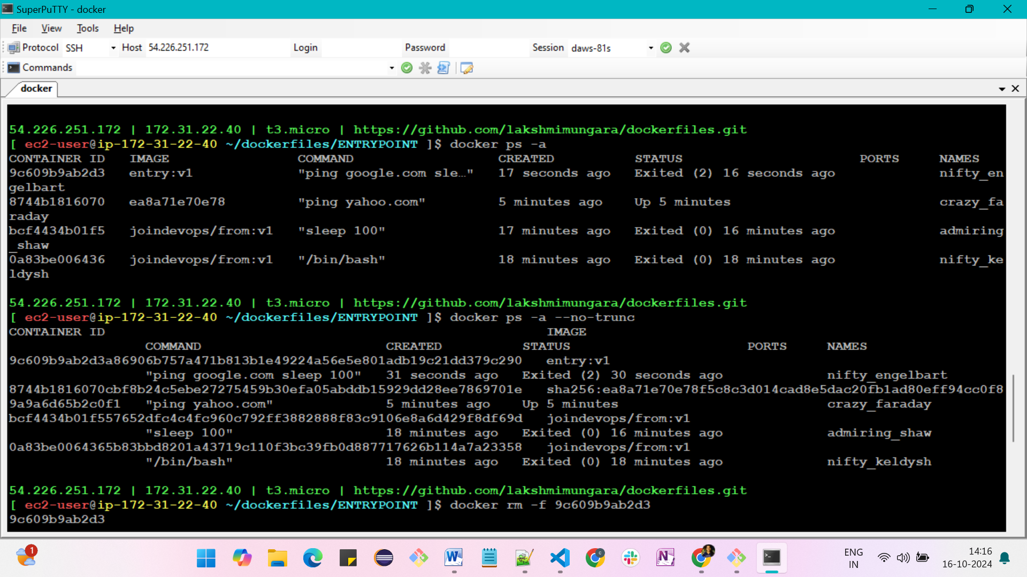

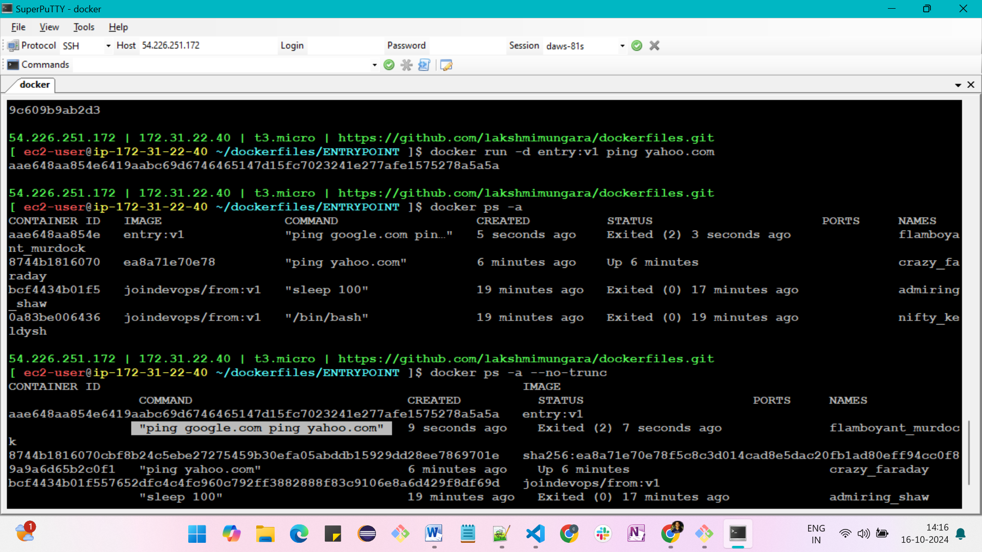

**ENTRYPOINT instruction**

**FROM almalinux:9**

**CMD ["ping", "google.com"]**

-> ping google.com -> which indicates google website is woring or not

-> CMD can be overriden at runtime

docker build -t entry:v1 .

docker run -d entry:v1

docker ps

docker logs -f <container-id> --> where -f for follow

docker rm -f <container-id>

docker run -d entry:v1 ping yahoo.com

docker logs -f <container-id>

**FROM almalinux:9**

**ENTRYPOINT ["ping", "google.com"]**

docker build -t entry:v1 .

docker run -d entry:v1

docker logs -f <container-id>

docker ps

docker rm -f <container-id>

docker run -d entry:v1 ping yahoo.com

docker ps -a

docker ps -a --no-trunc

-> You cannot override the ENTRYPOINT like CMD. If you try to do it will go and append to the entrypoint command

**FROM almalinux:9**

**CMD ["google.com"]**

**ENTRYPOINT ["ping"]**

docker build -t entry:v1 .

docker run -d entry:v1

docker logs -f <container-id>

docker ps

docker rm -f <container-id>

docker run -d entry:v1 ping yahoo.com

docker logs -f <container-id>

docker run entry:v1 ping microsoft.com --> dynamically

-> for better results and best practices. CMD can provide args to ENTRYPOINT, so you can mention default args through CMD and you can override them at run time

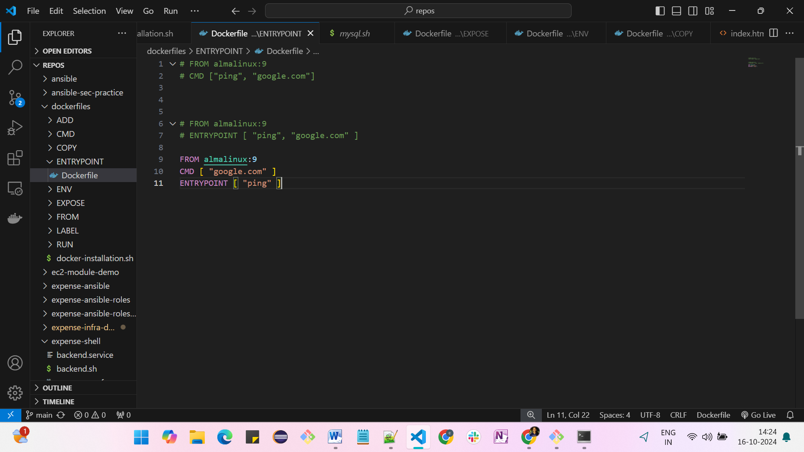

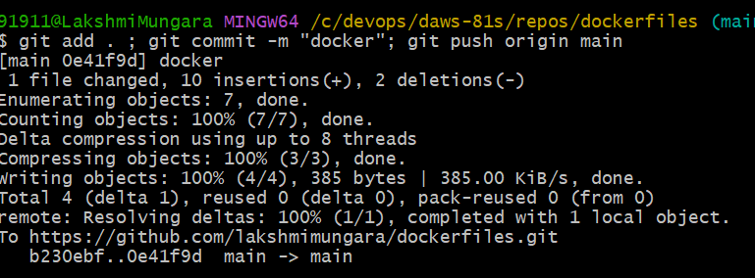

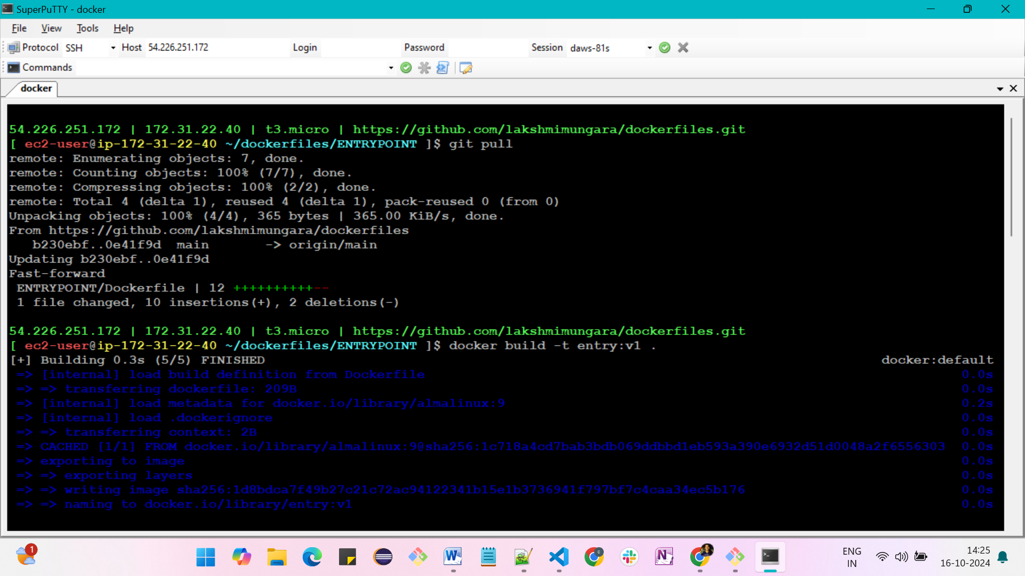

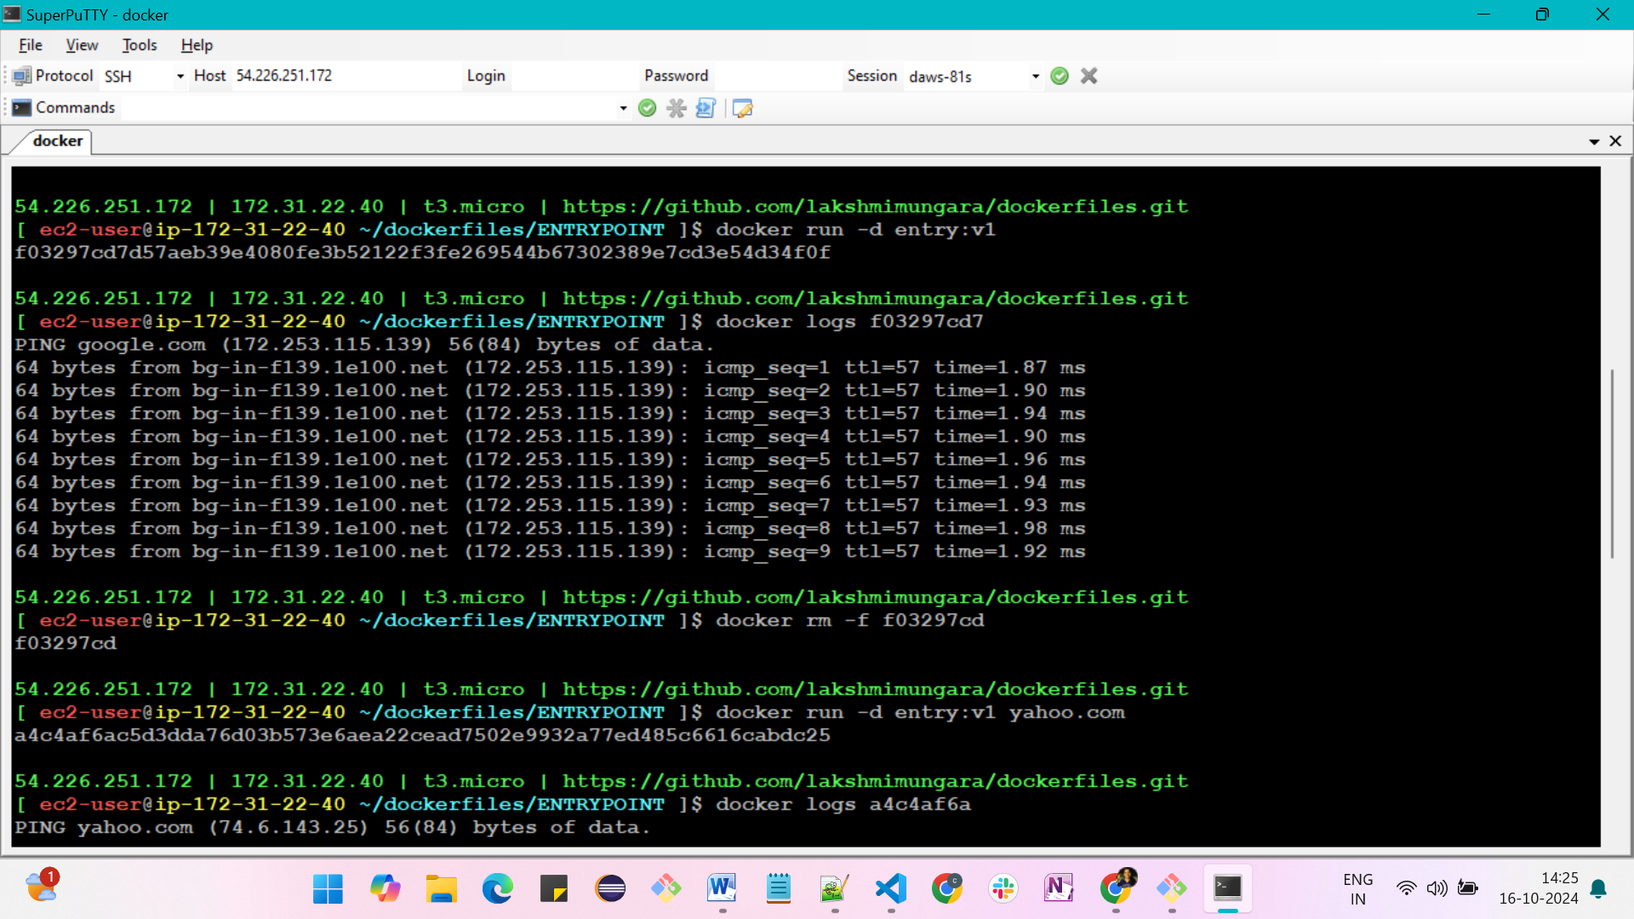

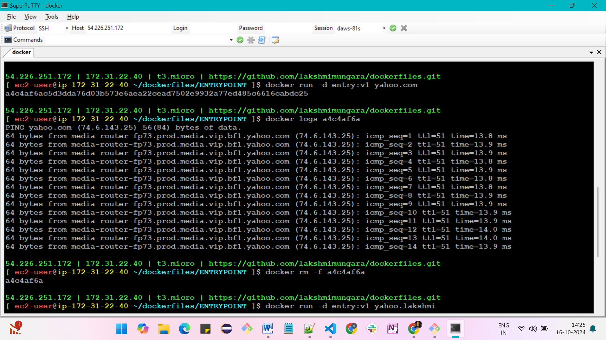

**Dynamically we can run any site**

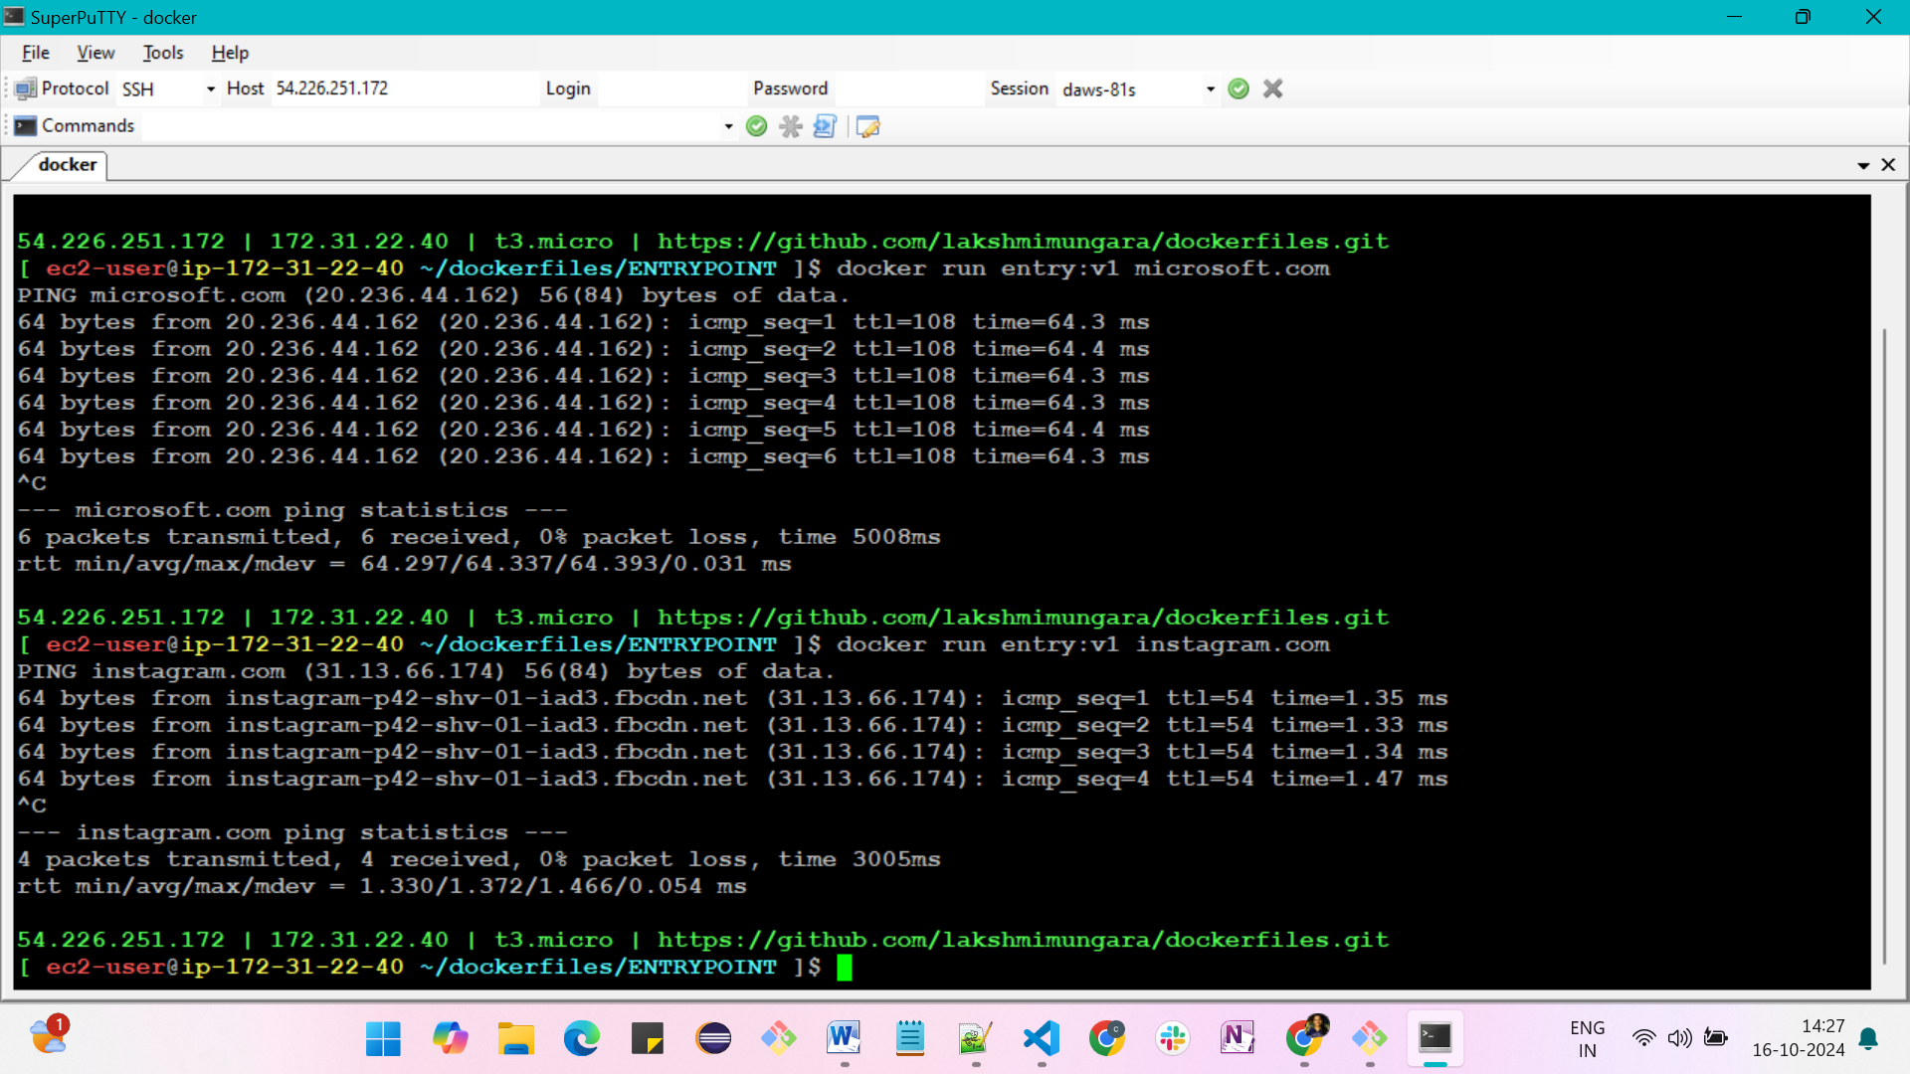

**USER instruction**

-> for security you should not run containers using root user, it must be on normal user. Atleast last instruction should be USER <some-username>

-> containers doesn't have any root access

-> container is a part of the host so it doesn't have seperate storage

**FROM almalinux:9**

**RUN dnf install nginx -y**

**CMD["nginx", "-g", "daemon off;"]**

docker build -t useR:v1 .

docker run -d -p 80:80 user:v1

docker exec -it <container-id> bash

-> Container doesn't have any seperate storage

-> If we given root access to container it can access host and can get some secuirty issues

-> USER instruction can be useful in this case

**FROM almalinux:9**

**CMD ["sleep", "100"]**

docker build -t useR:v1 .

docker run -d user:v1

docker exec -it <container-id> bash

-> this is not a best practice to take root acces

**FROM almalinux:9**

**RUN useradd expense**

**USER expense**

**CMD ["sleep", "100"]**

docker build -t user:v1 .

docker run -d user:v1

docker exec -it <container-id> bash

-> Now it is a normal user, we don't have any security issues

**FROM almalinux:9**

**RUN useradd expense**

**USER expense**

**RUN useradd expense1**

**CMD ["sleep", "100"]**

-> Here, 4th line doesn't work becoz, one user doesn't have permissions or access to add another user

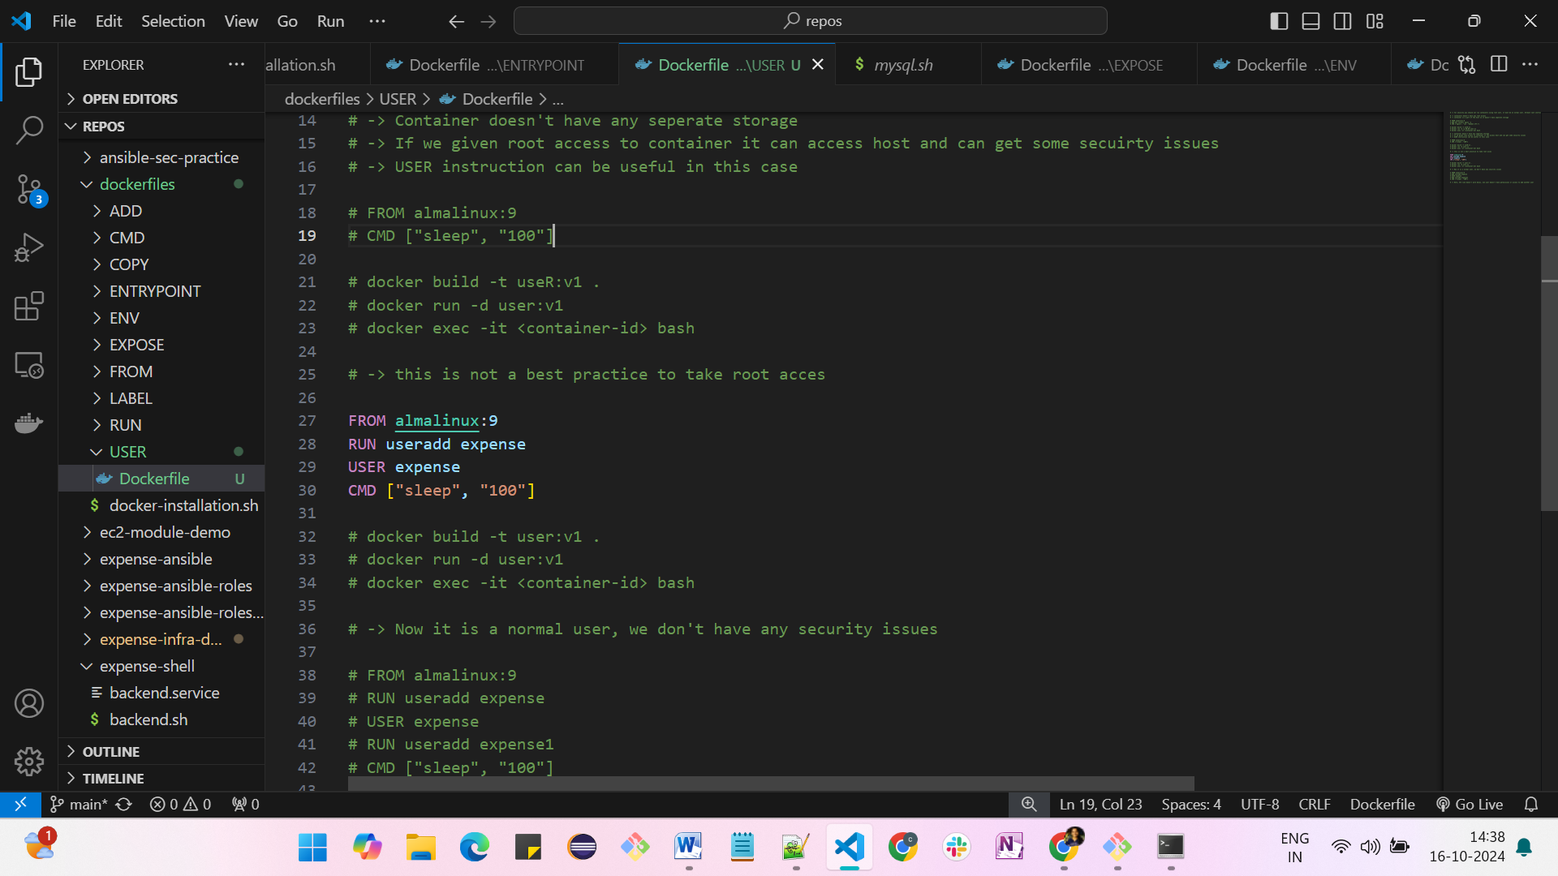

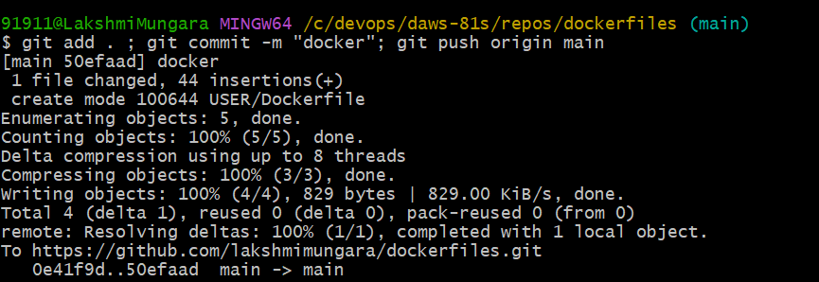

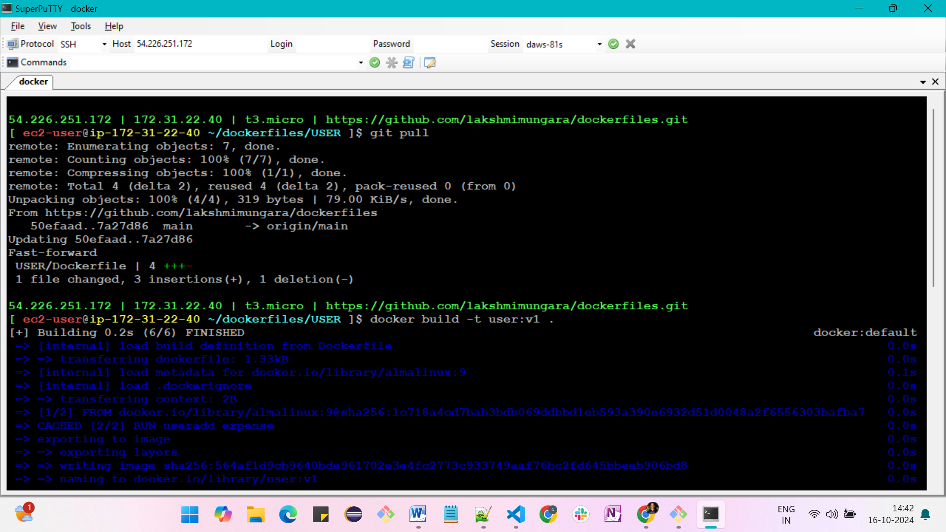

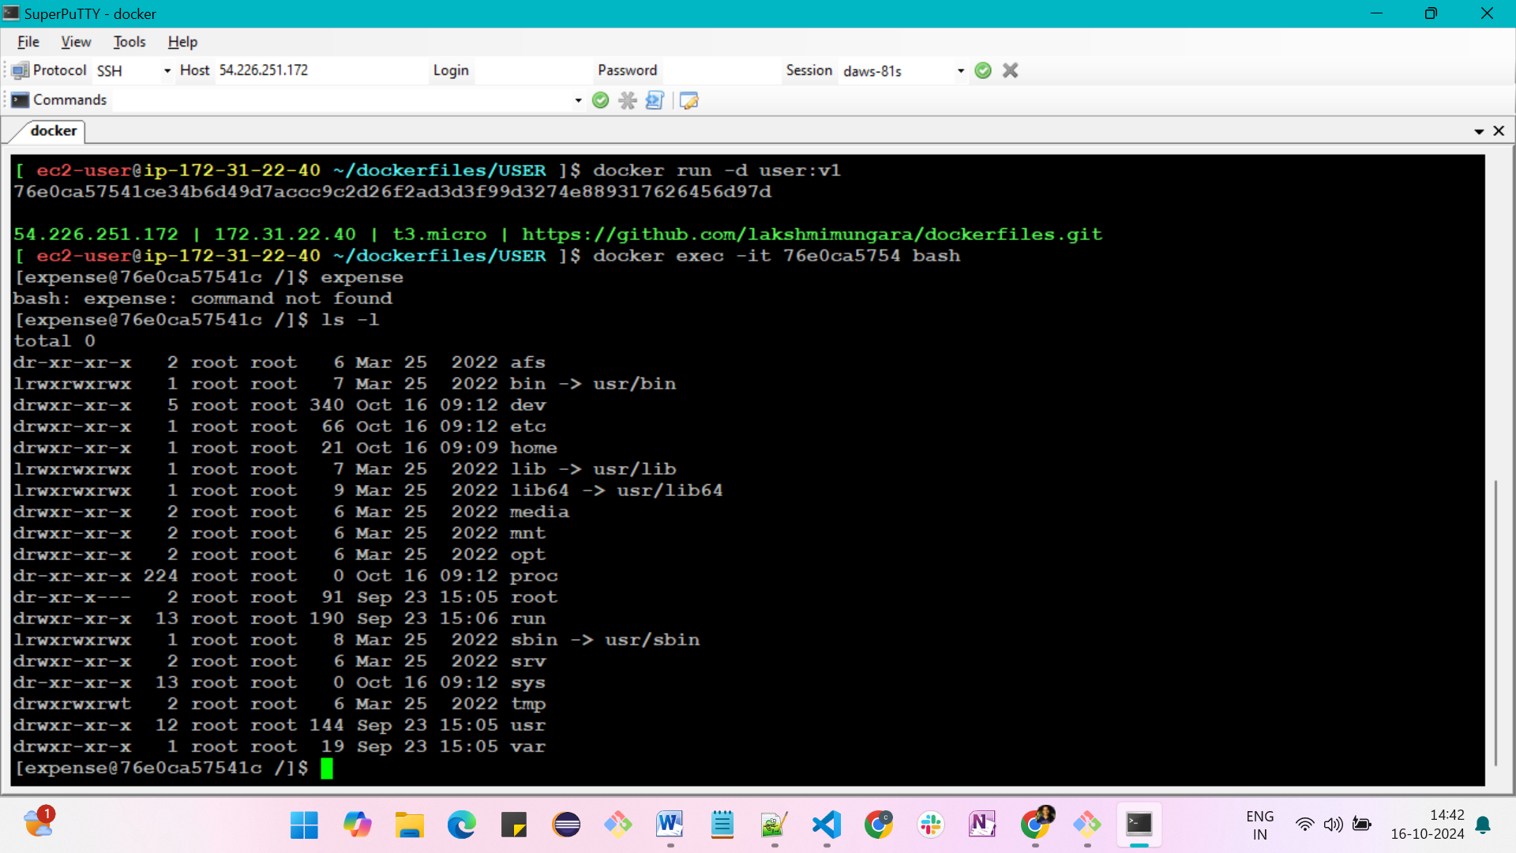

**WORKDIR instruction**

-> It is used to set the current working directory inside docker image

**FROM almalinux:9**

**RUN mkdir /tmp/docker**

**RUN cd /tmp/docker**

**RUN pwd #**

**RUN echo "Hello" > hello.txt**

**CMD ["sleep", "100"]**

docker build -t workdir:v1 .

docker run -d workdir:v1

docker exec -it <container-id> bash

find / -iname "hello.txt" -> It shows the where the file is located

cd /

ls -l

cat hello.txt

-> cd command doesn't work when we are going to move different directory. so, we are using workdir

**FROM almalinux:9**

**RUN mkdir /tmp/docker**

**WORKDIR /tmp/docker**

**RUN pwd**

**RUN echo "Hello" > hello.txt**

**CMD ["sleep", "100"]**

docker build -t workdir:v1 .

docker run -d workdir:v1

docker exec -it <container-id> bash

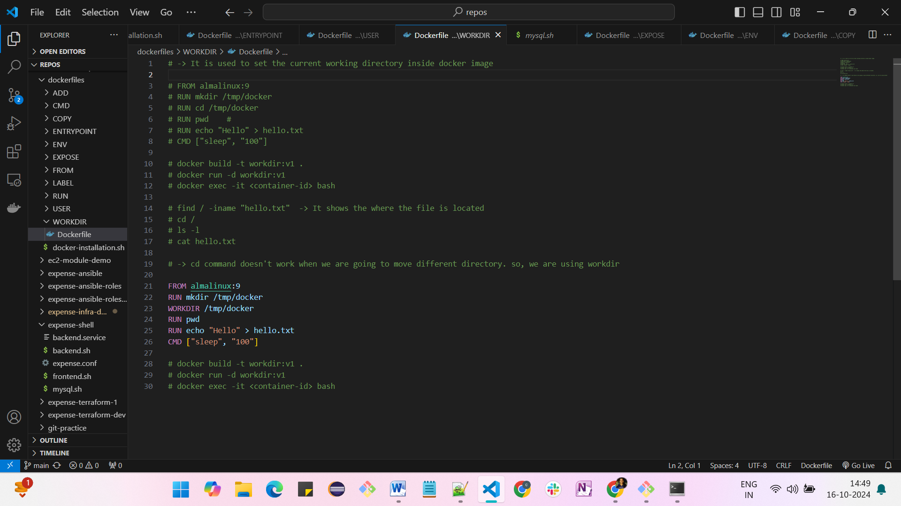

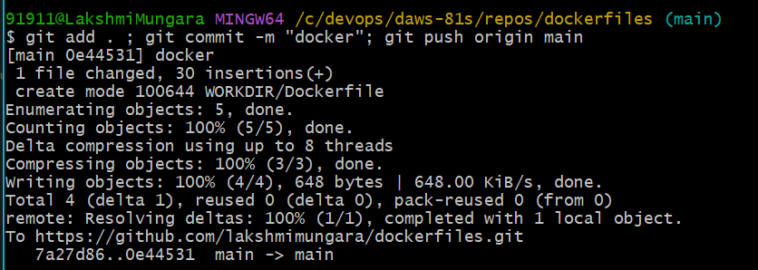

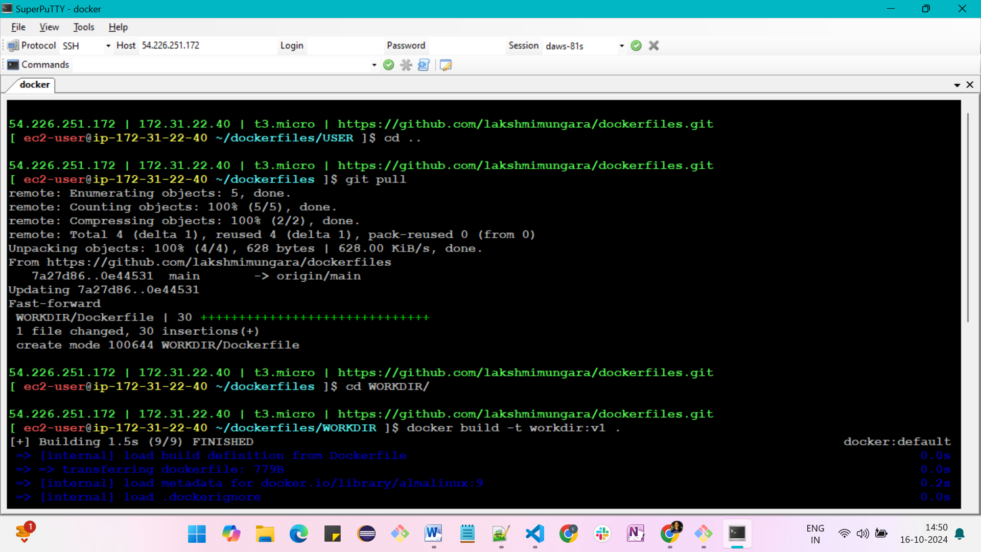

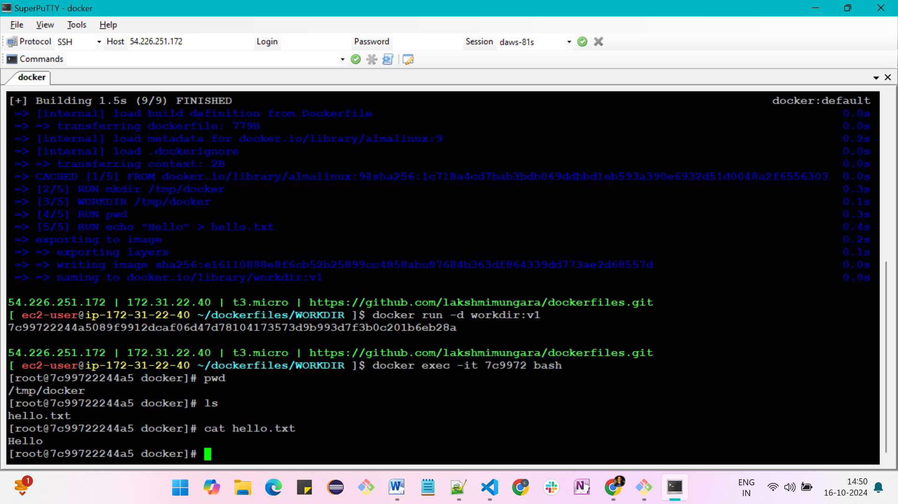

**ARG instruction**

-> It is used to set the variables at build time only, not inside the container

**FROM almalinux:9**

**ARG course="Devops with AWS" \**

**duration="2hrs"**

**RUN echo "course: $course, duration: $duration"**

**CMD ["sleep", "100"]**

docker build -t arg:v1 .

docker run -d arg:v1

docker exec -it <container-id> bash

-> ARG runs at the time of build

**FROM almalinux:9**

**ENV course="Devops with AWS" \**

**duration="2hrs"**

**RUN echo "course: $course, duration: $duration"**

**CMD ["sleep", "100"]**

ARG vs ENV --> most interview question

---------------------------------

1. ENV variables can be accessed in image build time and conatienr bash

2. ARG is only accessed at the time of image creation

3. You can use ARG instruction before FROM in one special case i.e to supply version to the bash image

4. ARG instruction before FROM is only valid until FROM, it can't be accessed after FROM

How can I access ARG values inside container?

--------------------------------------------

A) You can set arg value to env variable

ENV var-name=$var-name

**FROM almalinux:9**

**ARG course="Devops" \**

**duration="2hrs"**

**RUN echo "course: $course, duration: $duration"**

**CMD ["sleep", "100"]**

-> we can override the values from outside

-> docker build -t arg:v1 --build-arg course=docker .

**ARG version**

**FROM almalinux:${version}**

**ARG course="Devops" \**

**duration="2hrs"**

**RUN echo "course: $course, duration: $duration"**

**CMD ["sleep", "100"]**

-> docker build -t arg:v1 --build-arg course=docker --build-arg version=8 .

**ARG version**

**FROM almalinux:${version:-9}**

**ARG course="Devops" \**

**duration="2hrs"**

**RUN echo "course: $course, duration: $duration"**

**CMD ["sleep", "100"]**

-> default version

-> docker build -t arg:v1 --build-arg course=docker .

**ARG version**

**FROM almalinux:${version:-9}**

**ARG course="Devops" \**

**duration="2hrs"**

**RUN echo "course: $course, duration: $duration , version: $version"**

**CMD ["sleep", "100"]**

-> docker build -t arg:v1 --build-arg course=docker .

**ARG version**

**FROM almalinux:${version:-9}**

**ARG course="Devops" \**

**duration="2hrs"**

**ENV duration=$duration**

**RUN echo "course: $course, duration: $duration"**

**CMD ["sleep", "100"]**

-> docker build -t arg:v1 --build-arg course=docker .

-> docker run -d arg:v1

-> docker exec -it <container-id> bash

Type env

-> You can create ENV variable and set ARG to the variable

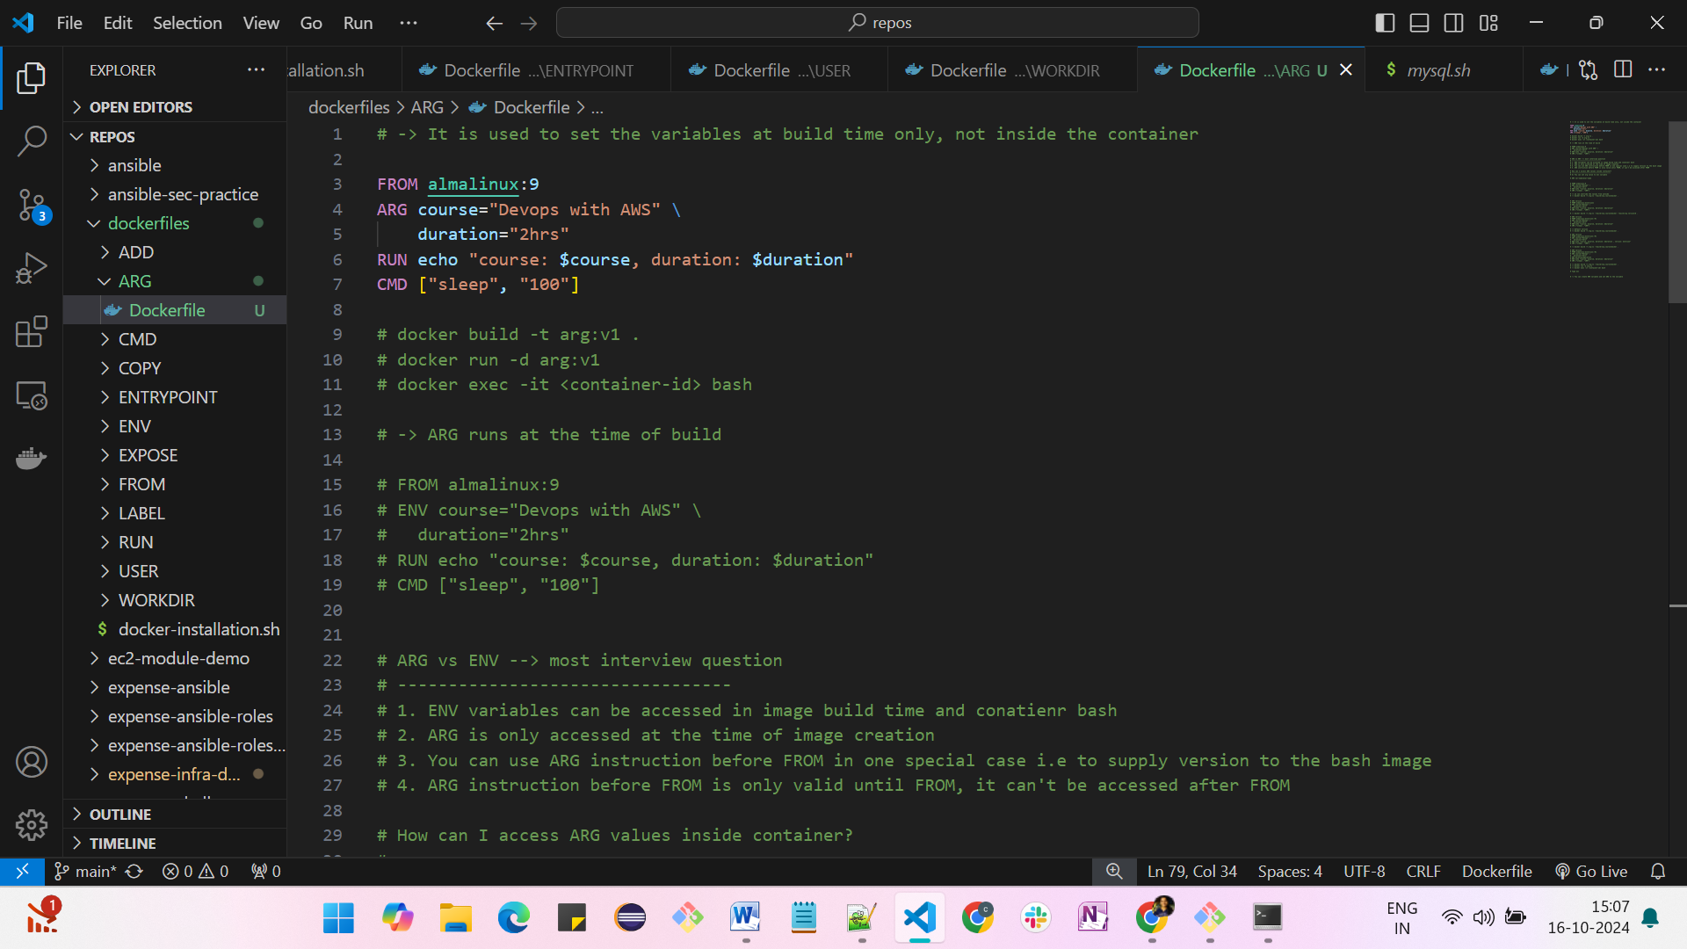

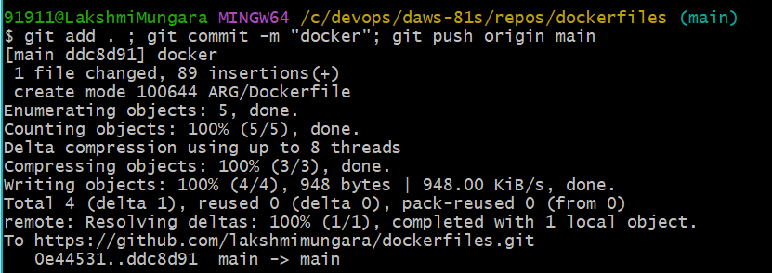

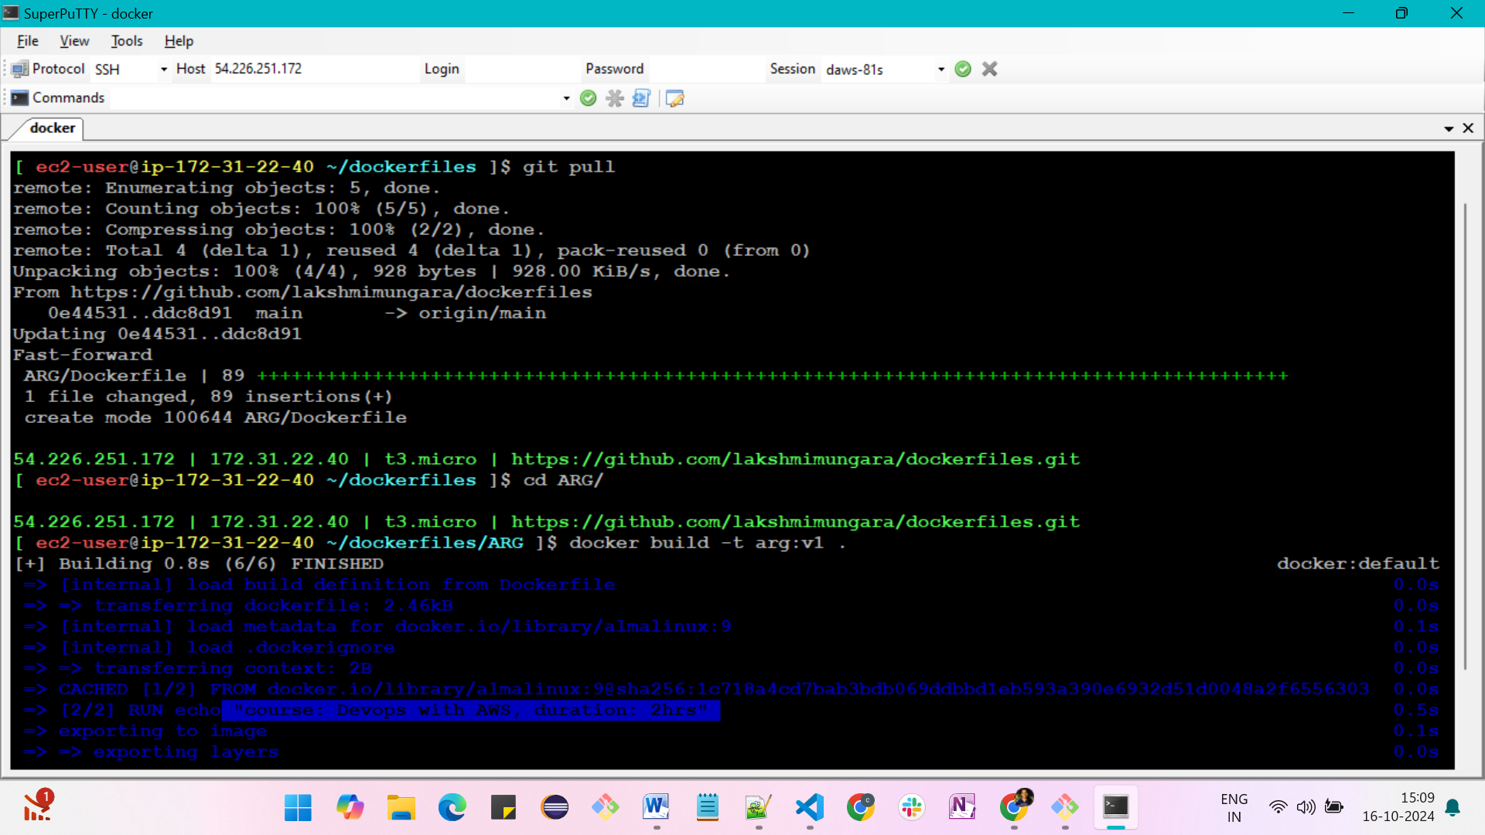

**ARG overrides**

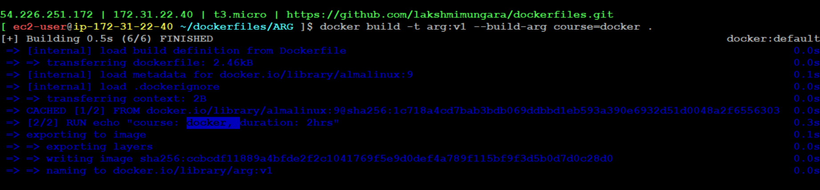

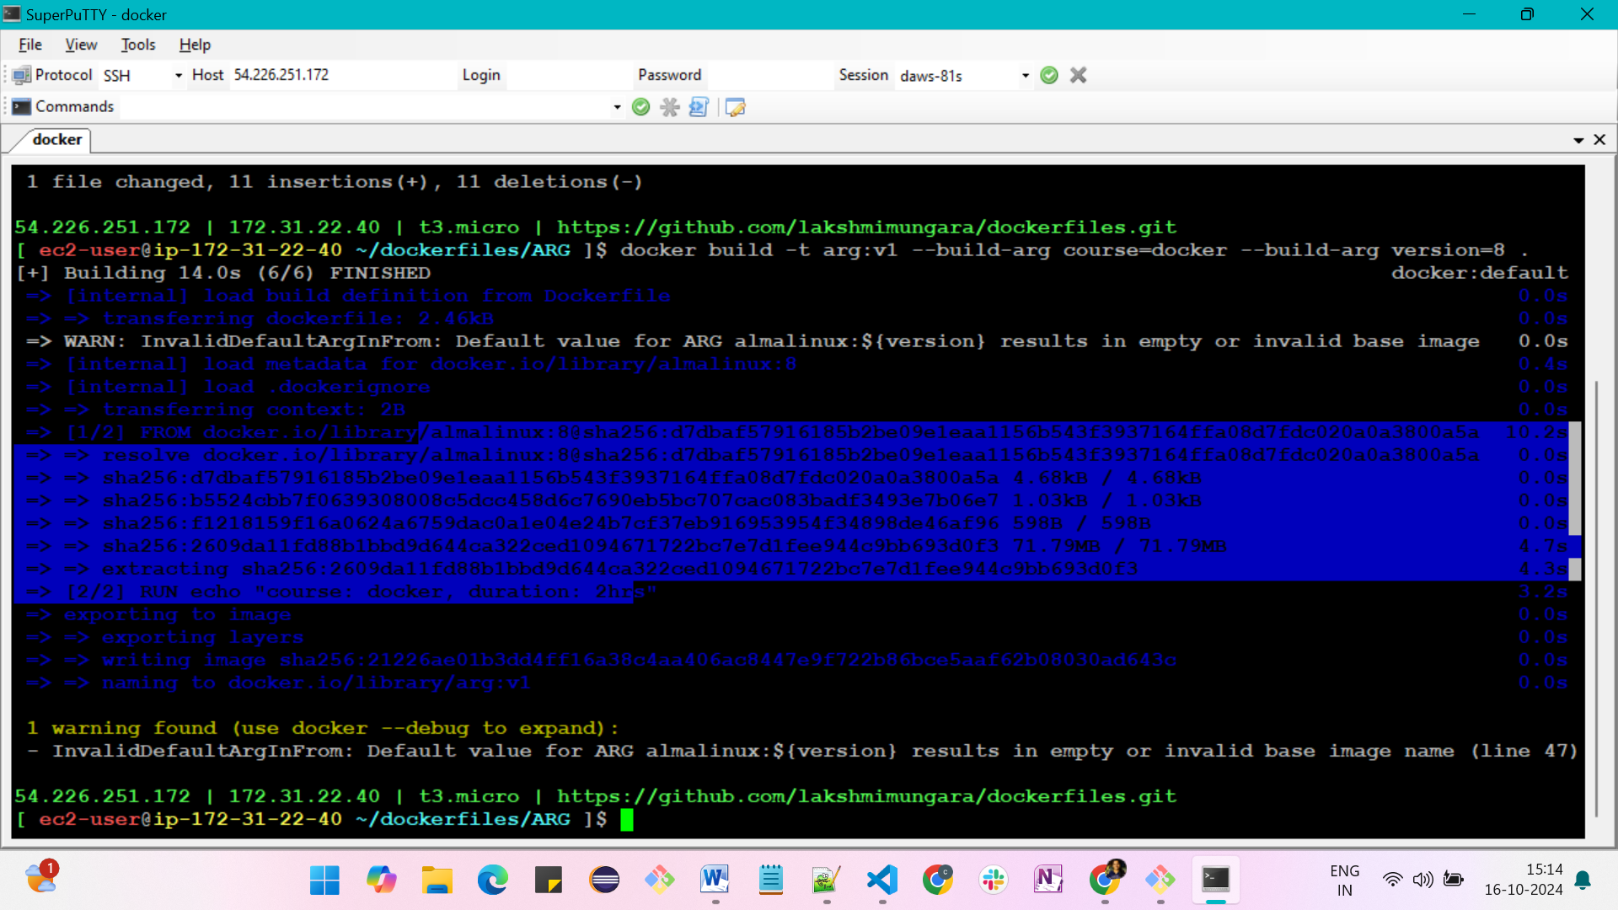

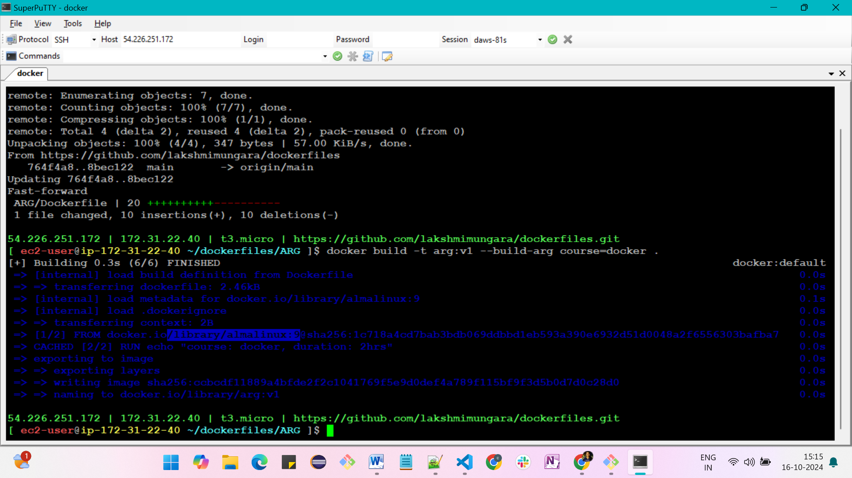

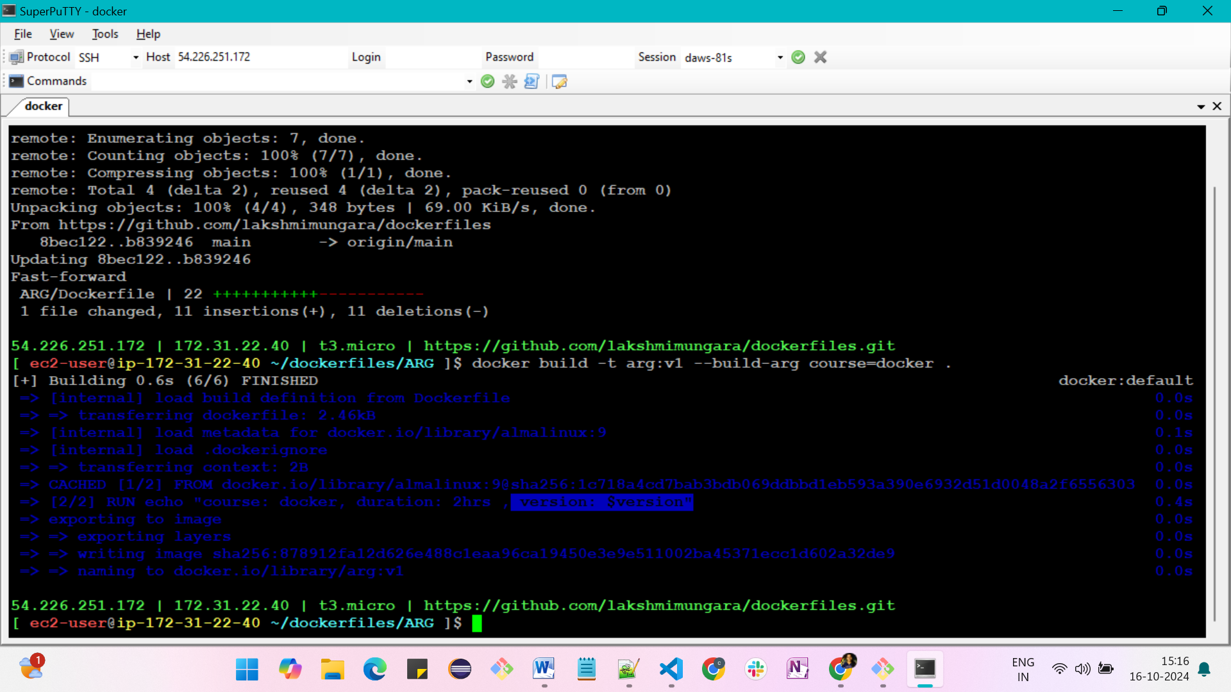

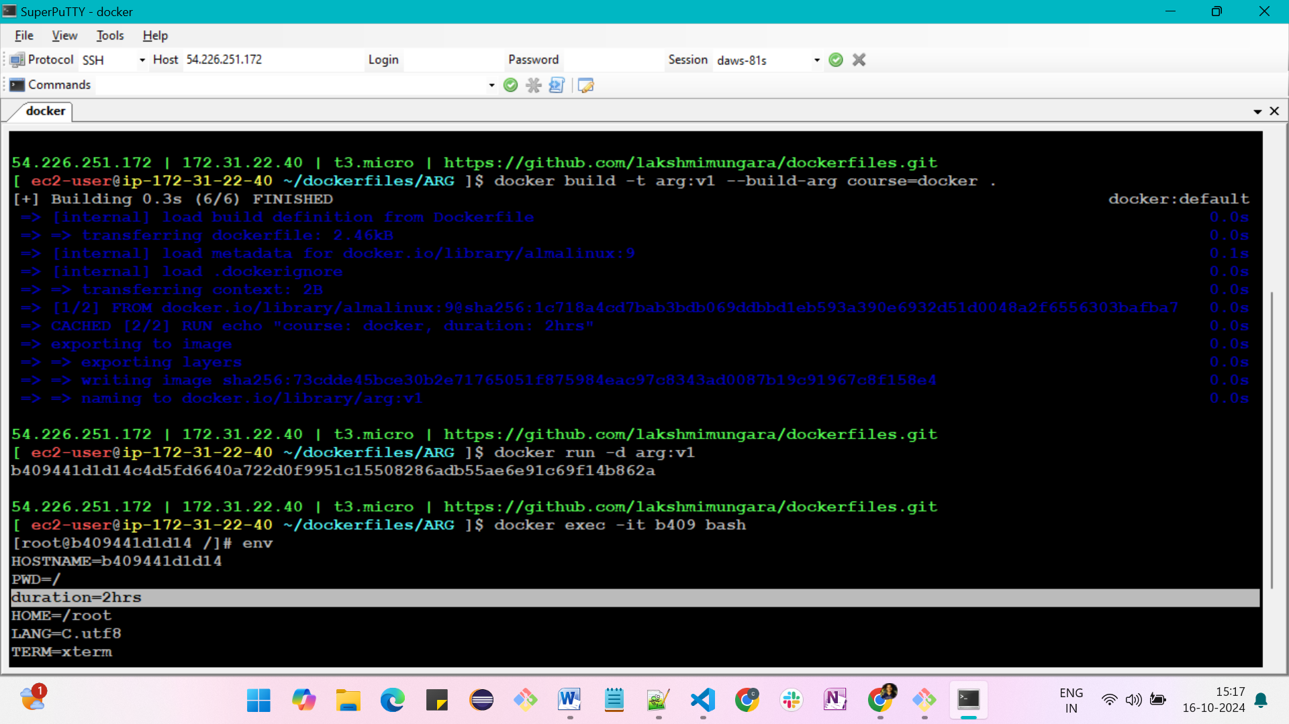

**ONBUILD instruction**

-> ONBUILD develops image adds to the image a trigger instruction to be excuted at a later time

-> It is used to trigger few instructions at build when a user is using our image

-> It doesn't trigger when the image author uses

**FROM almalinux:9**

**RUN dnf install nginx -y**

**RUN rm -rf /usr/share/nginx/html/index.html**

**# This onbuild instruction runs only, when any user uses the image**

**ONBUILD COPY index.html /usr/share/nginx/html/index.html**

**CMD["nginx", "-g", "daemon off;"]**

docker build -t onbuild:v1 .   
docker images

create another folder in vs code -> test and add the Dockerfile

FROM onbuild:v1

# we can take base image what we have created

cd test/

docker build -t onbuild:v1 .

-> we can use that image but have some conditions that we should keep index.html in our working directory

create index.html file and add content --> <h1>This image is created by onbuild base</h1>

docker build -t onbuild-test:v1 .

docker run -d -p 8080:80 onbuild-test:v1

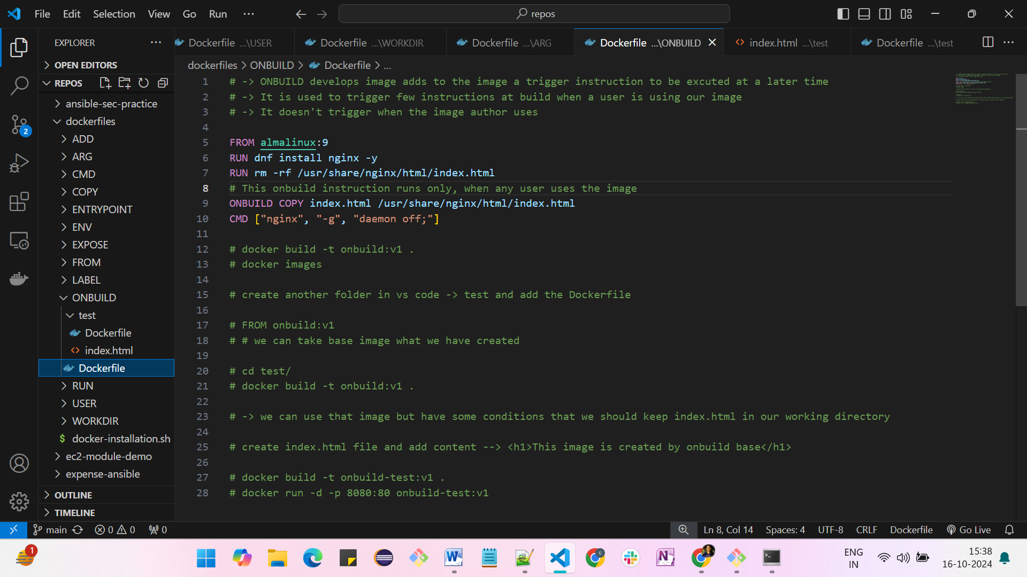

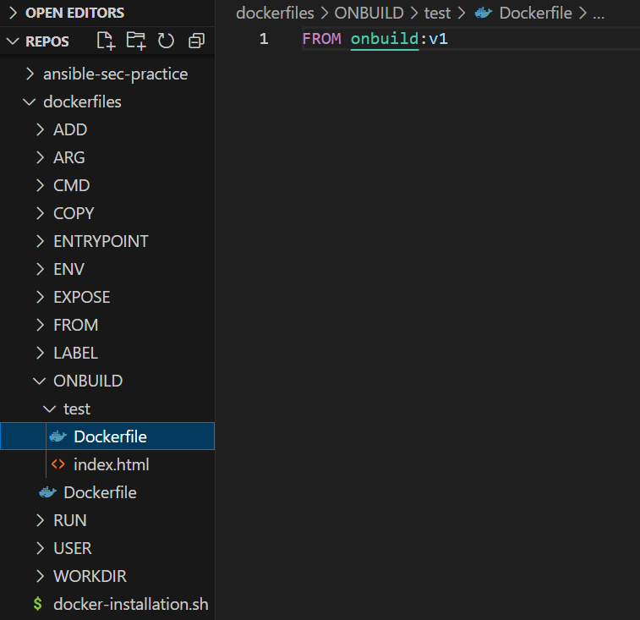

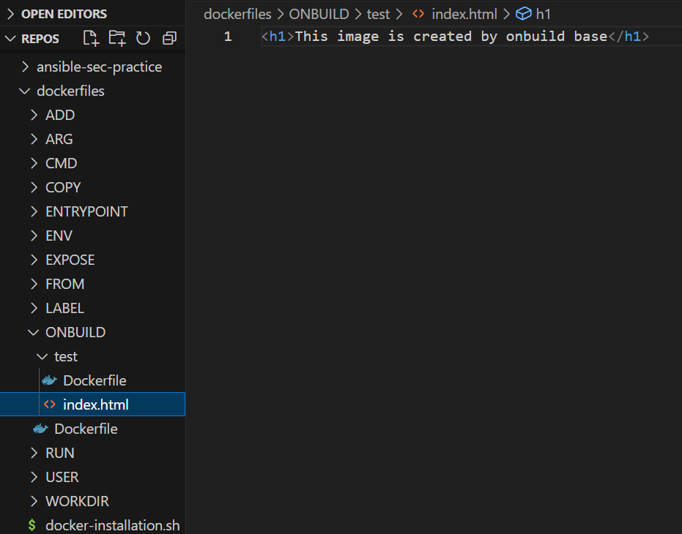

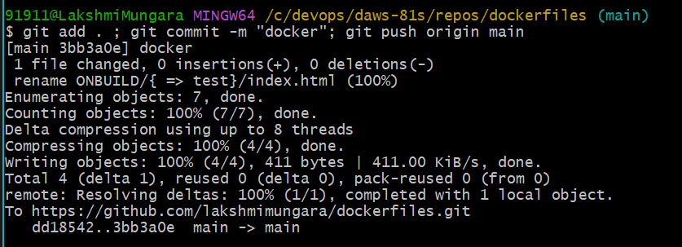

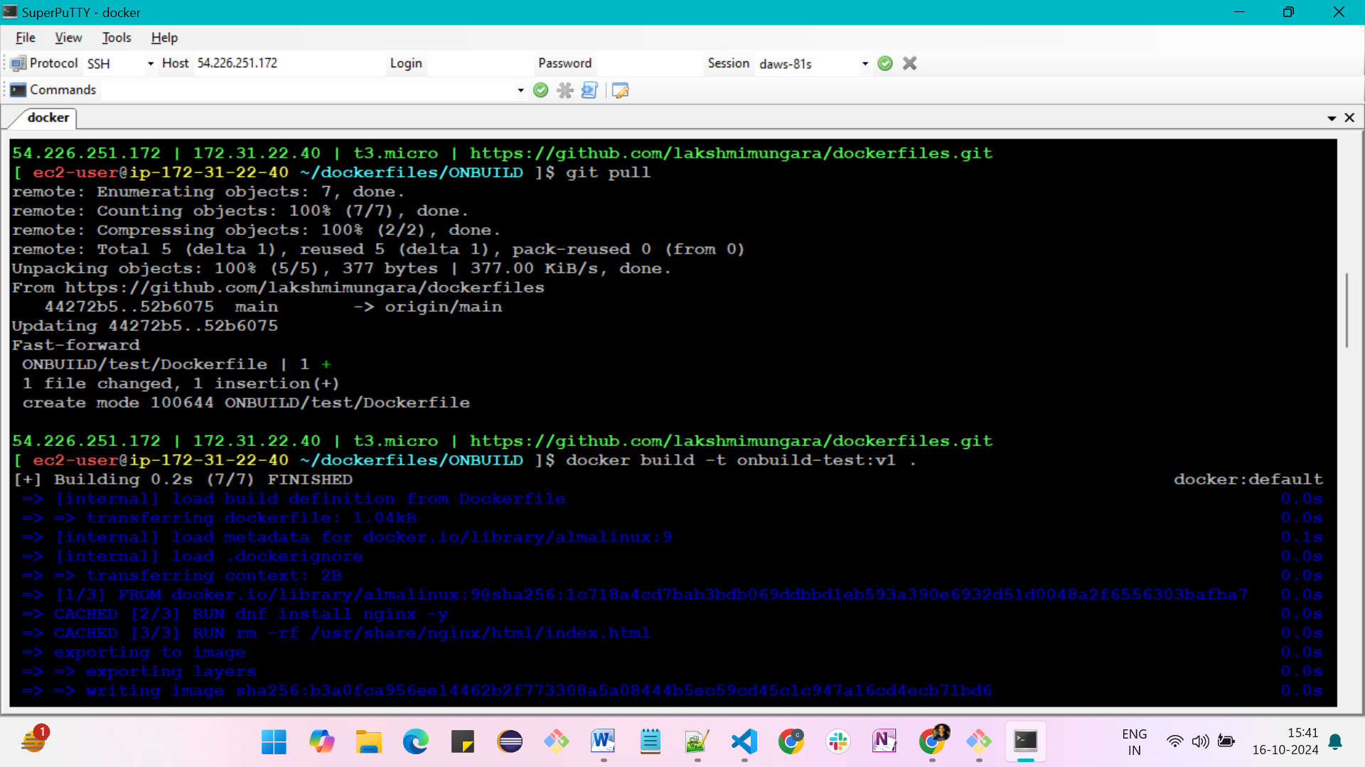

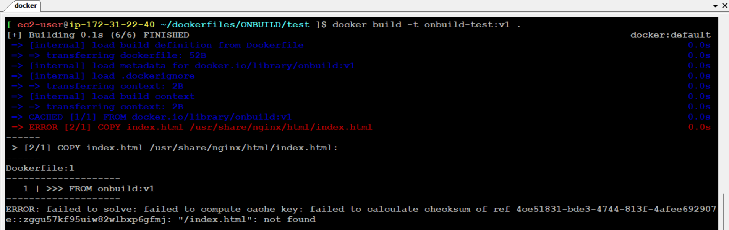

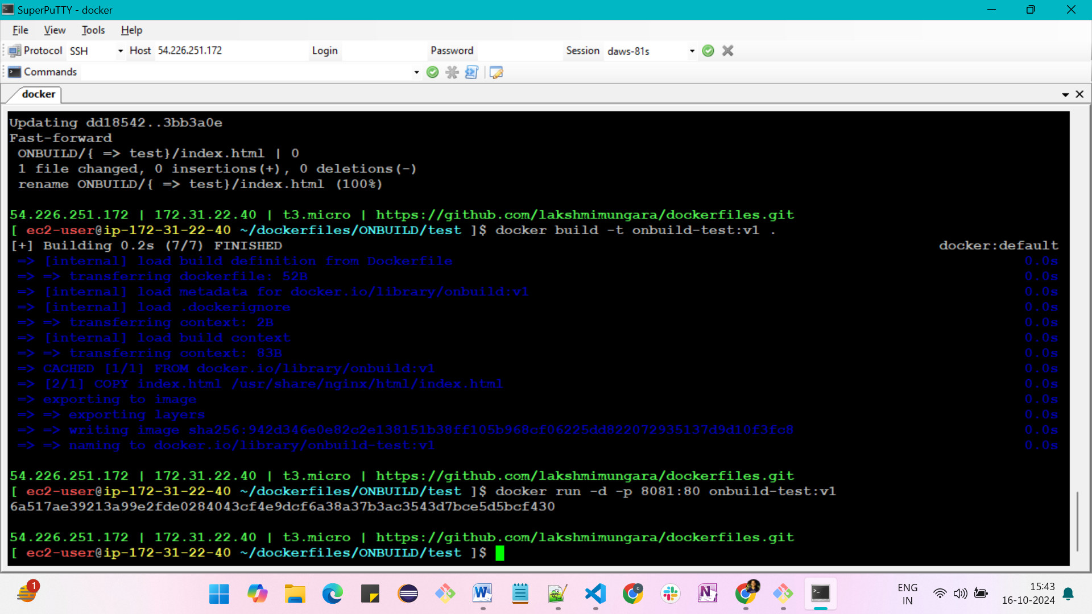

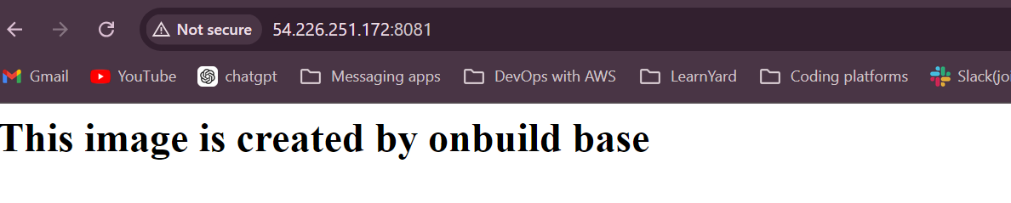

**Now, we doing our expense-project**



